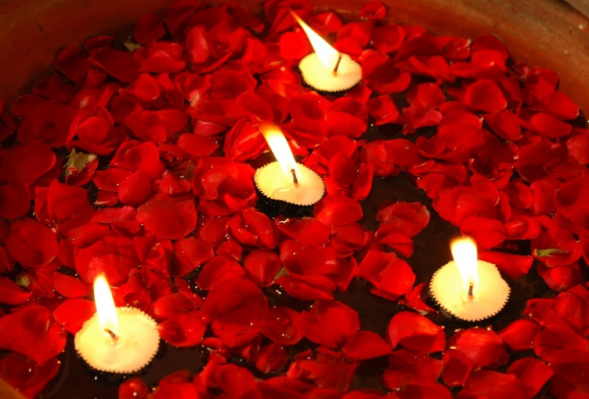 Current Staffing and Activity

- Funded Chaplaincy Hours – August 2014

Muslim – Imran, Fatima, Zeenat | 15 hours per week
Roman Catholic – Frs Peter (CRH) and Frs Ian, Chris and Rev Andrew (interchangeably) | 10.5 “ “ “
C of E / generic / management – George, Martin, Di and Lesley | 64 “ “ “
Free Church – George C (and a vacancy) | 22.05 “ “ “
Total | 118.5 hours per week  = 33.8 sessions (3.5 h)+  or  = 31.6 sessions (3.75h)+
Not forgetting Harbinder Singh (Sikh) and Damachani Prasadu (Buddhist) who are honorary chaplains – and our volunteers - who do it for nothing!
+ chaplaincy sessions are treated as comprising 3.5 hours in the 2003 Guidance but 3.75 hours in the new draft Guidelines. This latter fits better with the standard 37.5 hour contractual working week and makes it easier to talk about work on a day or ½ day rate.

We are also supported by an Admin worker who works for 18.5 hours for the Department. Her tasks include keeping track of the volunteers applying to work with us, liaising with church groups about Sunday worship, ensuring the team is up to date with mandatory training, correspondence on behalf of the team and managing supplies.
In Calderdale Royal a volunteer assists with administrative tasks such as collating and analysing information on pastoral visits undertaken, banking donations and mailshots. This greatly helps in freeing up chaplains for hands-on work.
A typical week for the chaplains looks like:-
Sunday | Monday | Tuesday | Wednesday | Thursday | Friday | Saturday
CRH  C of E chaplain s lead a.m. worship on two to three Sundays each month  HRI chaplain leads worship once a month | CRH  C of E chaplain a.m.  R.C. chaplain – a.m.  HRI  C of E chaplain 1. –all day  (supporting volunteers p.m.)  C of E chaplain 2 – a.m.  Muslim chaplain -a.m. | CRH  C of E chaplain 1 all day  C of E Chaplain 2 -p.m.  Muslim chaplain -a.m.  HRI  Free Church chaplain – a.m.  C of E chaplain 1 – all day  Sikh chaplain a.m | CRH  C of E chaplain 1 all day  Muslim chaplain -  2 hours  HRI  C of E chaplain 1 – all day | CRH  C of E chaplain 1 – a.m.  C of E chaplain 2 – p.m.  Sikh Chaplain a.m.  HRI  C of E chaplain 1 –  all day | CRH – covered from HRI  HRI  C of E chaplain 1 – all day  R.C. chaplain – p.m. | Both hospitals covered by out of hours on call system
On call p.m. and overnight | On call out of hours | On call out of hours | On call out of hours | On call out of hours | On call out of hours | On call during day and overnight
Note: 1. The Roman Catholic chaplains come into the hospital frequently in response to urgent
calls.
2. Chaplains (1) and (2) at CRH are currently employed on bank contracts following a vacancy
which arose June 2013.
3. A further vacancy arose in December 2013 due to the retirement of a Free Church
chaplain.
4. The Co-ordinating chaplain (denoted above as ‘HRI chaplain 1’) is based at HRI as the one
full-time chaplain
5. Female chaplain (2 hours) at HRI is currently on maternity leave.
6. The Muslim chaplain leads Jumma prayer in CHR or HRI on occasional Fridays.
7. The Sikh chaplain is a volunteer and visits Sikh patients and ward 21 generally.
7. The on-call provisions are discussed separately below.

b) Activity Analysis for the year 2013

1) Religious Care – from the Registers
Hope Centre-based services CRH + HRI | Bedside Support - Holy Communion  C of E / R.C | Bedside Support -Anointing / Sacrament of Sick
260 Sunday / midweek services / masses / Jumma Prayer | 786 all Christian denominations - HRI  363 all Christian denominations - CRH | 117 all Christian denominations – HRI  218 all Christian denominations - CRH
Other –  Meditation Group CRH – 52 meetings  Trust Carol Service  4 x Memorial Services for Babies (with SANDS)  1 Staff Memorial Service  2 ‘parallel’ funerals (patient too ill to attend actual funeral) | 4 Baptisms infant / adult CRH&HRI  3 Naming / blessing of babies  CRH | Muslim Last Rites / Birth Rites  8 HRI  - CRH

2) Pastoral and Spiritual Care – These services are used by both those with some religious
commitment and those with little affiliation:-

Support in grief and serious illness
Contract Funerals *- Babies  *= includes pre-funeral pastoral visit | Contract Funerals* - Adults | Out of Hours Calls
68 with parents attending (all faiths)  We also conduct a rite where no parents attend. | 12 | 48 C of E / Free Church  164 Roman Catholic  26 Muslim

Requested Visits
We respond to referrals made on patients’ behalf by ward staff, specialist practitioners, families and faith communities. Patients themselves also contact us for visits. Such referrals vary from about 25 to 55 a month (C of E / Free Church). A lot of this work involves repeat visits. Roman Catholic chaplains see around 80 – 100 patients per month in each hospital and our Muslim chaplains /spiritual advisers about 12 or 13 patients a month, often with repeat visits and community follow-up.

General Visiting – ward-based
This varies from checking with staff to see if there is anyone who might value a visit, seeing particular patients or undertaking a general ward ‘trawl’ (visiting most patients). This last way of working finds us engaging with patients who express no religious beliefs but wish to talk issues through, value a listening ear or simply want to express themselves in what can be a depersonalising environment. It takes time but is invaluable we, believe. It needs to be stressed that all visiting is done by consent, and we do not mind being told to go away! We believe in being as high profile as possible in the hospitals and that this availability encourages people to call on us to contribute to spiritual care generally.
Our female Muslim spiritual adviser visits the Maternity Unit frequently to develop the service to Mulsim female patients, and the Child Development Unit at CRH.

Involving Volunteers –

Leaders of Sunday Services  (in addition to chaplains conducting worship) | About 20 church groups from the Huddersfield area  4 clergy volunteer in CRH
Sunday Volunteers – co-ordinators and wheelchair pushers | CRH: 11 plus College students  HRI: 17 plus College students
Volunteers Visitors / Befrienders CRH+HRI  (N.B. all Trust volunteers are checked and screened. They are trained appropriate to their role.) | 5 Muslim  3 Sikh  1 Non-faith  18 Christian

4) Work with Staff – as well as being generally available to staff, chaplains support staff behind the scenes. This can be via self-referral or from managers.
Of course, chaplains are not the sole providers of spiritual care but can share with other staff in exploring how to deliver it. So we have led sessions in the following staff training over the past year: ‘Breaking Bad News’, ‘Coping with Raw Feelings’, ‘Coping with Baby Loss’ (for Hudds Uni Midwifery Course). Presentation on ‘ Compassion’ on Nurses and Midwives Day. We seek to offer this training as a team using different faith traditions where appropriate.

5) The Quiet Ministry – of our Hope Centres should not be overlooked. Our chapels, prayer rooms and quiet rooms are well used by those seeking some quiet and a place for reflection and prayer. Baby and Staff Memorial Books are kept open on today’s date in CRH, and the books left for intercession in both chapels are well used with entries made in them most days by patients and families.

This is information is compiled from material from the Registers of Services, funeral records and records of ward visiting. We are seeking to standardise our record-keeping on both sites for easy access to facts and figures.
Note from the above:-
a) 68 funerals for miscarriages, stillbirths and neo-natal deaths: Each funeral requires a domiciliary visit to get to know parents, offer support and plan the service, preparing and liaison with the funeral director about the service, preparing a service sheet (which is often a valued memento to go in the Memory Box) and then conducting the service. Follow up support is welcomed.
b) Group Memorial Services to remember babies (reducing to three as the summer service is to be an open-air balloon release for the whole catchment area). We undertake three a year; each involves preparation with the local SANDS group members, hospital staff and other volunteers. The Christmas service in Huddersfield is part of the “Lights of Love” initiative, where acts of remembering take place nationwide on a given date. Due to the numbers attending we now do this in a local church.
c) 104 Sunday Services – 51 undertaken by hospital chaplains. A rota is drawn up each year with the community groups / individuals who come in to lead worship. We value this community engagement but it requires some maintenance on our part on drawing up the rota, checking participants are prepared, providing resources and supporting the hospital volunteers who help visitors out and collect patients on Sundays.
d) Teaching /training slots. Here we present ourselves in a different mode – often ‘sans collar’ – as persons involved in holistic support of patients and working alongside staff to assist in facilitating their care-giving. More recent developments have been regular input into the End of Life Care training (6 sessions a year) and our co-ordinator has become a ‘Prevent’ trainer.

