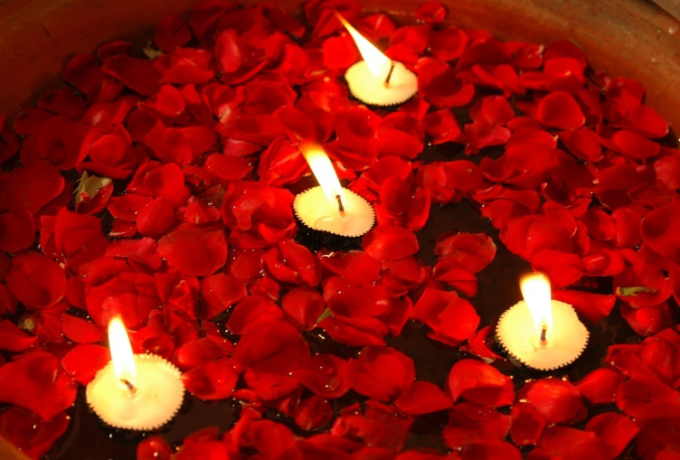Team Discussion 30-10-2013
What we do well
Emergency visits / on call / baby services and care / ward and individual visiting (see below) / Sunday services / volunteers (see below) / admin functions / care of staff / holistic view of work and availability to all / answering faith-specific issues and working within a variety of cultures. Maintaining a presence. Role of educating – formal and informal – helping with study days. Networking with interfaith councils and their constituents – keeping webpages up to date re: guidelines for staff.

Issues from Team Discussion
- Communications
Between Bev and chaplains – time wasted looking for info already on shared drive.
Where are people and what are we doing – not clear.
Share all diaries via computer? Especially useful for funerals (problem when part time people are v part-time – appropriate to put all other work on diary?)
Some duplication of work – visiting same patients, etc.

- Pressures on Chaplains
Not enough time to do everything. Baby funerals and meetings / teaching sessions can use up a p/t chaplains week! Likewise undertaking duties on behalf of the team – drawing up rota / publicity / etc. Never able to take hours back which are owed.
Responding to on call / calls for help when not on call or when over hours. Feeling we need to be responsive though to meet pastoral and spiritual care needs.

- Problems with the Service
How we gain referrals – ‘cold’ calling v referred patients and skills different for each.
More follow up of bereaved parents?
Management functions ‘squeezed in’. Acknowledgement that this eats away at work of visiting / services etc.
Should we be making a case for resources based on stats?
Faith-community visiting v. generic visiting/ resource for all

Where we want to be
Recognise that a lot of things we do well. Keep doing them!
Better able to support staff with faith-based and culturally-based input.
For minority ethnic groups – outreach / raise profile of chaplaincy.
Project clearer understanding of role of chaplaincy by others.
Volunteer visitors – how do we use them? Are they integrated?
Promote Continuing Professional Development – training but personal dev too.

Action Plan
Working with the Strategy of the Four ‘Pillars’

- ‘We put the Patient First’
What stops us covering the ground?
What helps us see things from patients’ point of view?
Are we delivering what patients / visitors / staff want?
Are we working well with community contacts?
Patient visiting – how do patients find this? Are meeting needs? Are we contributing to their experience of hospital in a positive way?

- ‘We ‘go see’’
Patient visiting – how do patients find this? Are meeting needs? Are we contributing to their experience of hospital in a positive way?

Short Patient Survey
Short Staff Survey
Short Survey of Bereaved Parents (those attending Memorial Service?)

- ‘We work together to get results’
Are we representatives of our faiths first or chaplains first?
What can we do together and what do we do apart?
Are we working well with volunteers?
Is our resourcing equitable in things like on call?
Are we talking to the right people in the organisation / in the community?
Do we recognise different roles (management / admin) in team and support that?

- ‘We do the must do’s’
For us this is more about identifying our core activities.
Have we clear priorities for what we do and how?
Can we facilitate achieving these priorities?
Is our communication effective within the team and to those outside it?
Can we identify training / hold practice sessions to address issues?
Ownership of CPD.
Getting a handle on time-management and not attempting the undoable!

