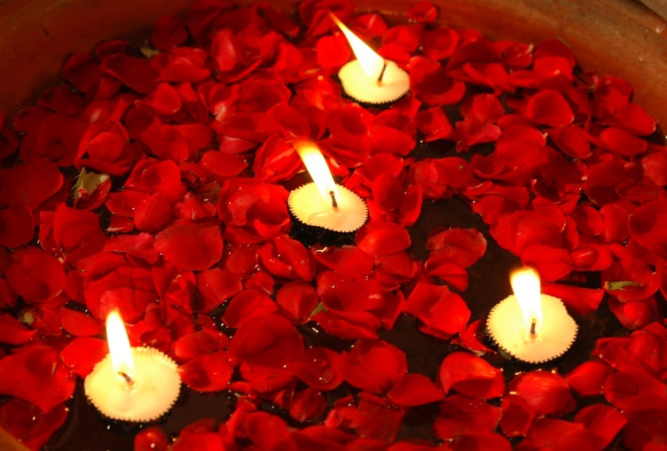 We ‘go see’
As part of our ‘going and seeing’ we have consulted with those in other chaplaincies in Bradford (19/5/14) and Bolton hospitals (5/6/14).

The Bradford Experience
We visited Bradford Hospitals and met their chaplains. The department represents well the different religious and cultural backgrounds and we met Muslim, Christian and Sikh chaplains. Over the past 15 years there has been a rise and fall in the resources allocated to chaplaincy of all faiths. At the highpoint there were 69 ½ hours per week of Muslim chaplaincy, 7 hours Hindu and 7 hours Sikh but this has fallen back to 53 ½ hours of Muslim and 3.5 hours of both Hindu and Sikh chaplaincy. The Christian input has fallen from 3 full time posts to one post, plus 7 hours of specific Roman Catholic input. Such changes have been as a result of chaplains leaving posts and cuts in funding. It seems rather than any deliberate policy to favour one faith group over another the current situation has come about as posts fell vacant and were not filled.

It is not really appropriate to make statistical comparisons with our own situation as our hospitals and areas are very different, but we learnt some things:-

- The Department there is wondering how to make savings of 6% in the current year, short of cutting back on salaries.
- Income-generation schemes (indiscriminately conducting funerals) were felt to be detrimental to the department and its purpose, and have been abandoned.
- Much of the chaplains’ time is spent undertaking Cultural Competence Training with staff.
- A lot of time is spent on seeking to engage with sections of the local population and their expectations of healthcare. Some similarities with our situation we recognized - such as the wish to have the body of a deceased patient quickly released from hospital, and the implications of fasting in Ramadhan for attending appointments.

- Chaplains worked in two ways using (admittedly inaccurate) lists of patients, and grading general visits to units as twice a week, weekly, fortnightly or occasional.
- The Imam (also the co-ordinating chaplain) spent time with staff (22% of which are Muslim) and patients where “rulings” were needed on Muslim practice.
- On-call was shared all the way round the department and patients were helped as much as a possible by a person of faith, with specific follow up from the patient’s own faith representative as soon as possible. There was no cover at weekends.

We gained the impression the chaplains felt they worked in a ‘reactive’ way much of the time with little opportunity for service development and initiative. We wonder where this leaves the function of chaplaincy to get out there and seek to meet the needs of those of all faiths and none.

From talking to colleagues from Bolton Hospitals Trust we conclude:-
- That all chaplains need to uphold the distinctive nature of chaplaincy as being a service for all. We need to work on re-establishing a ‘link’ system where a representative of the Department leads in the delivery of services to a specific ward / area.
- Greater accuracy in our assessment of patient/staff needs and the recording of our involvement. We need to be able to account for our work and be audit-able. This may involve looking at I T systems, but certainly involves better and consistent record-keeping across both sites.
- Our commitment to interfaith working needs affirming – “visiting on behalf of the department” - and robust systems for passing specialist work on to colleagues within trusting relationships.
- We need to look at appropriate recognition of volunteers and who is accorded ‘honorary chaplain’ status.
- Devising an Operational Policy
- All of the above contribute to creating a shared vision and how we are going to work towards it.
Conclusions
We have learnt from the above and included actions in our forward planning.

