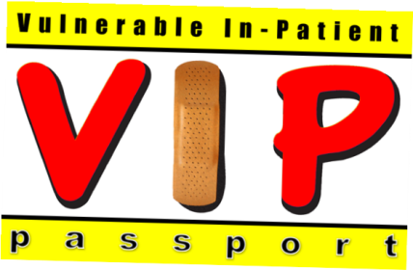
VIP hospital passport
This VIP Passport gives the hospital staff important information about you.
Please make sure you give as much information as possible to help the health professionals in hospital provide you with individualised care to meet your specific needs.

My NHS number:……………………………………………………………………………….
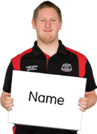 | My full name is : ...........................................................................................  I like to be called: ........................................................................................
My religious needs are: ................................................................................

My ethnic background is: .............................................................................
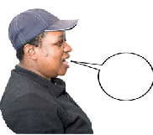 | Language/s I speak: ............................ Understand: ....................................  Language/s my carer speaks: ....................... Understands: ............................
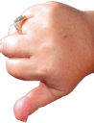 | Tell us the things you like to do and talk about: | Tell us what you don’t like to do or talk about:

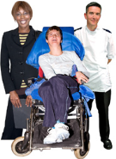 | Other services involved with me: (social services, other health services, other). Please give telephone numbers:

Date .............................................. Review date ............................................

© Produced with partners by the Kirklees Valuing People Team

 | Tell us your medical conditions and anything we should know about your health.
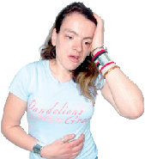 | Allergies or sensitives?
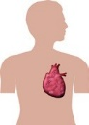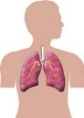 | Tell us about any operations
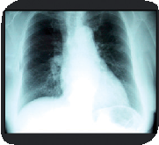 | Tell us the best way to support you to have medical interventions
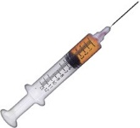 | Tell us if you are scared of needles and how we can help you.
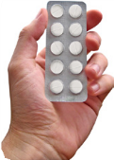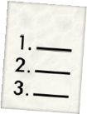 | Tell us how you take your medication: (crushed, injected, syrup, with food, other)  Please bring a list of the  medication you take now.
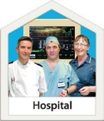 | Tell us about the reasonable adjustments you need in hospital

How I communicate
 | Tell us how you communicate.
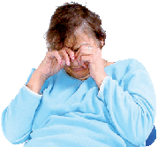 | Tell us how you display been worried or angry and how we can help you.

Tell us how you show signs of pain verbally and non-verbally.

Tell us about your hearing/sight:

Tell us what we need to do to help you to understand, for example easy read leaflets or using videos.
Eating and drinking
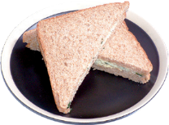 | Tell us about what we need to know to support you to eat, do you have a specific plan or use special equipment?  ..................................................................................................................................................................................................................................................................................................................................................................  Foods I like: .................................................................................................  Foods I don’t like: ........................................................................................  Special diet: ......................................................................................................
Tell us about how we need to support you to drink, do you have a plan or any equipment needs?
....................................................................................................................

Drinks I like: ................................................................................................

Drinks I don’t like:........................................................................................

Specific risks associated with choking:

 | Tell us how to help with you with your personal care:
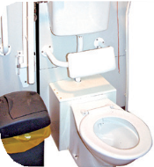 | Tell us how to support you with going to the toilet or meeting your continence needs?
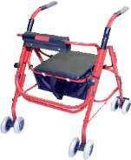 | Tell us about your mobility and any specific needs you have?
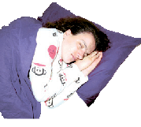 | Tell us what we need to do to help keep you safe:

Leaving hospital

When planning for you to go home who do need to talk to, what things do we need to consider?
Do you need support to get home from hospital?
Yes No
I Consent to share my passport with health professionals who are supporting me with my care and treatment:
Signature………………………………………………………………..Date:……………………………….

Or a best interest decision has been made because I lack capacity:
Date………………………………………………………………………………………………………
Signature/designation……………………………………………………………………………..

