
Calderdale and Huddersfield

NHS Foundation Trust

Patient Safety Incident Response Plan
(PSIRP) 2025-27

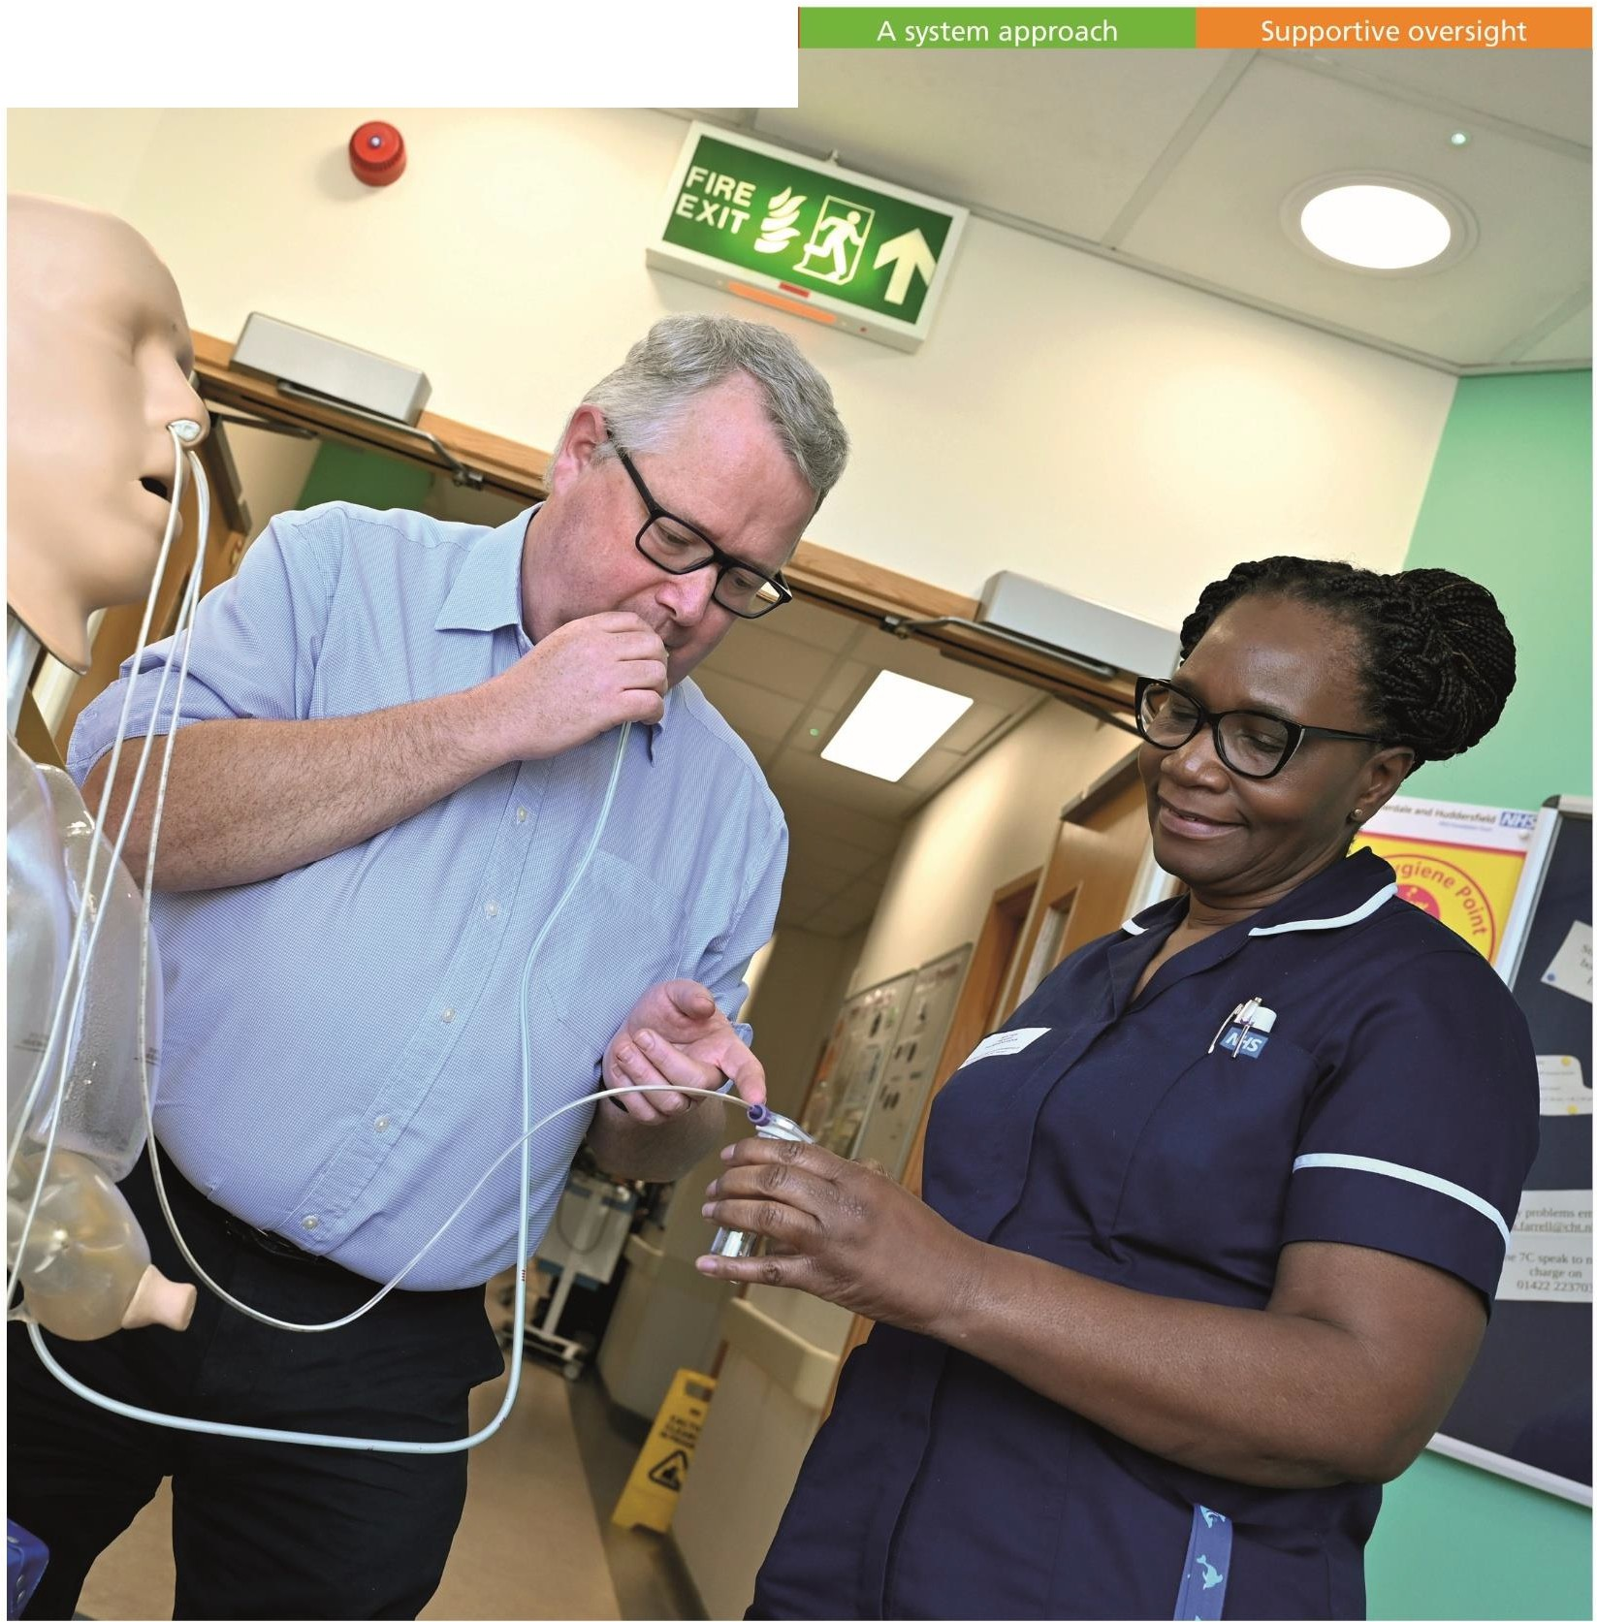
Compassionate involvement Proportionate response


one

Patient Safety Incident Response Plan
Effective date: 01 October 2025
Review date: 30 September 2027

 | NAME | TITLE | SIGNATURE | DATE
Author | Sharon Cundy | Head of Quality & Patient Safety | 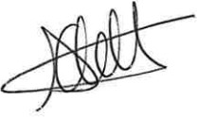 | 01.10.25
Reviewer(s) | Joanne Middleton | Deputy Chief Nurse |   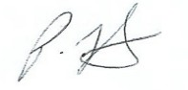     | 01.10.25
 | Paula Flint | Deputy Chief |  | 01.10.25
 |  | Nurse
 | Elizabeth Morley | Associate |  | 01.10.25
 |  | Director for
 |  | Quality and
 |  | Safety
 | Nikhil Bhuskute | Deputy Medical |  | 01.10.25
 |  | Director
Authoriser(s) | Lindsay Rudge | Executive Chief Nurse | 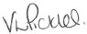  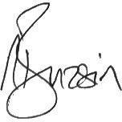 | 01.10.25
 | Victoria Pickles | Director of |  | 01.10.25
 |  | Corporate Affairs
 | Neeraj Bhasin | Executive Medical |  | 01.10.25
 |  | Director

Document Summary Table
Unique Identifier Number | G-142-2024
Status | Ratified
Version | 2
Implementation Date | 1 March 2024
Current/Last Review Dates | 1 September 2025
Next Formal Review | 30 September 2027
Sponsor | Chief Nurse
Author | Head of Quality and Patient Safety
Where available | Trust intranet
Target audience | All staff
Ratifying Committees
Name of ratifying committee |  |  | Date of meeting
Executive Board |  |  | 09.10.25
Consultation Committees
Committee Name Quality Committee  Calderdale ICB Kirklees ICB |  | Committee Chair  Denise Sterling Non- Executive Director  Lucy Dryden, Head of Quality  Siobhan Dorotiak, Head of Quality | Date of meeting  9 October 2025  28 Feburary 2024  28 Feburary 2024
Other Stakeholders Consulted
Stakeholders who were consulted on this document
Does this document map to other Regulatory requirements?
Patient Safety Strategy NHS England
Associated Trust policy or procedural documents.
- Patient Safety Event Response Framework Policy

Contents
EXECUTIVE SUMMARY 4
Introduction 6
Our Services 6
Purpose, scope, aims and objectives: 9
Situation Analysis (National) 10
Situation Analysis (Local) 12
Defining our patient safety improvement profile: 13
Trust Learning 21
National Priorities: 21
Incident reporting arrangements 23
Procedures to support patients, families and carers affected by patient safety incidents 23
Health Inequalities 255
Promoting a Just Culture 277
Procedures to support staff affected by patient safety incidents: 28
Mechanisms to develop and support improvements following patient safety investigations: 29 Evaluating and monitoring outcomes following patient safety investigations and reviews 29
PALS & Complaints 30
Roles and responsibilities 30
Summary: 355
Appendix A: Terms and abbreviation 36
Appendix B: Learning Responses 367
Appendix C: HMC Cover Sheet 42
Appendix D: Incident Review Process 43
Appendix E: Levels of Care 44

EXECUTIVE SUMMARY
Over the past 18 months, Calderdale and Huddersfield NHS Foundation Trust (CHFT) has been transitioning to the Patient Safety Incident Response Framework (PSIRF)— a significant and exciting shift in how the Trust approaches patient safety. PSIRF removes the traditional distinction between ‘patient safety incidents’ and ‘serious incidents’, enabling a more holistic and inclusive view of safety events. This approach supports continual learning from both what goes right and what does not, ensuring that every experience contributes to safer, more effective care.

Central to this transformation is the development of a strong patient safety culture— one where staff, patients, and families feel safe and supported to speak openly. CHFT recognises that conversations with patients and families, particularly following safety events, can be difficult. However, by fostering psychological safety and equipping colleagues with the right tools and support, the Trust is committed to helping staff feel confident and capable in these moments.

PSIRF has fundamentally changed how CHFT responds to patient safety events. The Trust has adopted new learning responses that prioritise system-wide improvement over individual blame. These responses ensure that insights are captured and translated into meaningful change, driving continuous learning improvement across services.

This transition reflects CHFT’s commitment to transparency, compassion, and learning. By embedding PSIRF into everyday practice, the Trust is building a safer, more responsive healthcare system—one that learns, evolves, and places patients at the heart of everything it does.

Lindsay Rudge, Executive Chief Nurse

Introduction
The NHS Patient Safety Strategy was published in 2019 and describes the PSIRF, a replacement for the NHS Serious Incident Framework. The Serious Incident Framework provided structure and guidance on how to identify, report and investigate an incident resulting in severe harm or death. PSIRF is best considered as a learning and improvement framework with the emphasis placed on the system and culture that support continuous improvement in patient safety through how we respond to patient safety incidents.

One of the underpinning principles of PSIRF is to do fewer “investigations” but to do them better. Better means taking the time to conduct systems-based investigations by people that have been trained to do them.

The NHS Patient Safety Strategy challenges us to think differently about learning and what it means for a healthcare organisation.
The PSIRF supports the development and maintenance of an effective patient safety incident response system that integrates four key aims:

- Compassionate engagement and involvement of those affected by patient safety incidents.
- Application of a range of system-based approaches to learning from patient safety incidents.
- Considered and proportionate responses to patient safety incidents
- Supportive oversight focused on strengthening response system functioning and improvement.

These four strategic are the basis of how our second edition of the Trust PSIRP has been developed. The strategic aims are aligned with our own four behaviour pillars that support ‘one culture of care’ and the transition over to PSIRF continues to see both the strategic aims and our Trust behaviours embodied in our work.

CHFT aims to create an environment and culture of openness, trust, and honesty. We encourage and celebrate diversity because broader perspectives, skills, experience, and knowledge will enrich and enhance the value we bring to each other, our patients/clients, and other stakeholders.

Our Services
CHFT employs almost 7,000 staff who deliver compassionate care from our two main hospitals, Calderdale Royal Hospital and Huddersfield Royal Infirmary as well as in community sites, health centres and in patients’ homes. We also are incredibly proud to have around 170 volunteers here at CHFT.

We provide a range of services including urgent and emergency care; medical; surgical; maternity; gynaecology; critical care; children’s and young people’s services; end of life care and outpatient and diagnostic imaging services.

We provide community health services, including sexual health services in Calderdale from Calderdale Royal and local health centres. These include Todmorden Health Centre and Broad Street Plaza.

In 2023/24 we cared for more than 114,000 men, women and children as inpatients (who stayed at least one night) or day cases. There were also more than 480,000 outpatient attendances; almost 178,000 accident and emergency attendances and more than 4,300 babies delivered.

Our Maternity Services:

Calderdale and Huddersfield NHS Foundation Trust is one of the UK’s providers of integrated hospital and community-based healthcare providing a comprehensive range services to the residents of Calderdale and Kirklees in West Yorkshire.
Maternity care is provided at Calderdale Royal Hospital and the service has approximately 4300 births a year across the labour ward, co-located birth centre and homebirth service. The labour ward has eleven birthing rooms with one additional labour room housing a birthing pool, and the birth centre has seven birthing rooms, two of which have birthing pools. In addition to these areas, our maternity service also has a 24-hour Maternity Assessment Centre, 31 bedded mixed antenatal and postnatal wards with four transitional care beds and 20 cot level two neonatal unit.

Governance arrangements within the Maternity and Neonatal services are in line with the Trust and the Divisional Governance Frameworks to ensure consistency and effectiveness.

We continue to modernise and invest in our health services to build on our strong reputation.

This document is our second edition of the Trust Patient Safety Incident Response Plan (PSIRP) that incorporates our Maternity and Neonatal services. This plan should be read in conjunction with the Patient Safety Incident Response Policy.

The PSIRP outlines CHFTs approach to developing and maintaining effective systems and processes for responding to patient safety events and it describes the activities that we have undertaken to refresh and update our first PSIRP from April 2024.

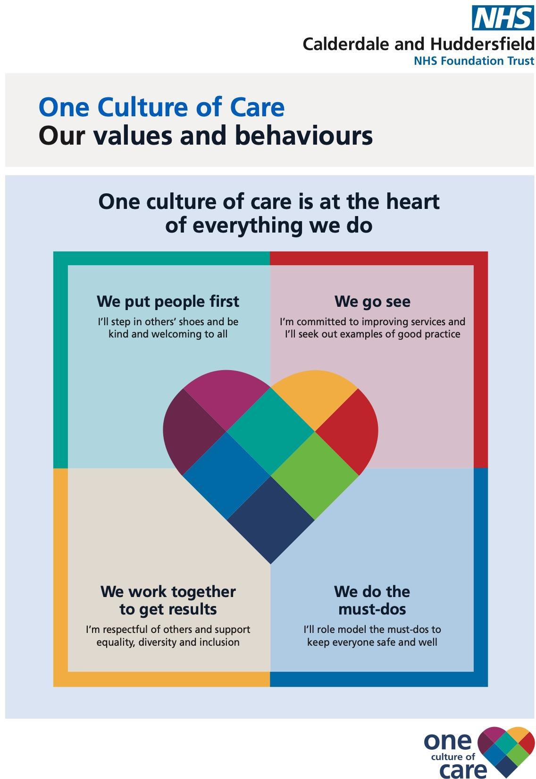
Calderdale & Huddersfield NHS Foundation Trust Vision and Values

Purpose, scope, aims and objectives:
Purpose:
The Trust PSIRP sets out how CHFT will respond to patient safety events reported by service-to-service referrals, our staff, patients, their families, and carers as part of the work to continually improve the quality and safety of the care we provide. The plan will remain flexible and consider the specific circumstances in which patient safety issues and incidents occurred and the needs of those affected.
This document should be read alongside the introductory Patient Safety Incident Response Framework (PSIRF) 2020 (NHS England » Patient Safety Incident Response Framework ), which sets out the requirement for Trust PSIRPs to be developed.

Scope:

This plan explains the scope for a systems-based approach to learning from patient safety incidents. There are many ways to respond to an incident. This document covers responses completed solely for the purpose of system learning and improvement.
Patient safety events relate to any unintended or unexpected incident which could have or did lead to harm for one or more patient’s receiving healthcare. There is no remit to apportion blame or determine liability, preventability, or cause of death in a response completed for the purpose of learning and improvement.

Complaints, Human Resource (HR) matters, legal claims, and inquests have their own processes and are outside the scope of PSIRF .

We have developed the planning aspects of this PSIRP with several stakeholders, both internal and external to CHFT. The aim of this approach is to continually improve. As such this document is not a fixed plan that cannot be changed, it will remain flexible and consider the special circumstances in which patient safety events occurred and the need of those affected.

Strategic Aims:
There are four strategic aims of PSIRF, and these are aligned with the Trust’s four pillars.
CHFT four pillars of behaviour
We do the must-dos
We work together to get results
We go see
We put people first

PSIRF
Improve the working environment for staff in relation to their experiences of patient safety incidents and investigations.

Improve the use of valuable healthcare resources
Improve the experience for patients, their families, and carers wherever a patient safety incident or the need for a PSII is identified.

Improve the safety of the care we provide to our patients
National Aims

6
Page 9 of 4

Strategic Objectives:
CHFT continues to develop a climate that supports a just culture¹ and an effective learning response to patient safety events/incidents. The Trust will make more effective use of current resources by transferring the emphasis from the quantity of investigations to a higher quality, more proportionate response to patient safety events. The aim is to:

- make patient safety incident investigations more rigorous and, with this, identify causal factors and system-based improvements.
- engage patients, families, carers, and staff in investigations and other responses to incidents, for better understanding of the issues and causal factors.
- develop and implement improvements more effectively.
- explore means of effective and sustainable spread of improvements which have proved demonstrably effective locally.

¹ A culture in which people are not punished for actions, omissions, or decisions commensurate with their experience and training, but where gross negligence, wilful violations and destructive acts are not tolerated. Eurocontrol (2019) Just culture.

Situation Analysis (National):
Background:
Many millions of people are treated safely and successfully each year by the NHS in England, but evidence tells us that in complex healthcare systems things will, and do, go wrong, no matter how dedicated and professional the staff.
When things go wrong, patients are at risk of harm and many others may be affected. The emotional and physical consequences for patients and their families can be devastating. For the staff involved, incidents can be distressing and members of the clinical teams to which they belong can become demoralised and disaffected. Safety incidents also incur costs through lost time, additional treatment, and litigation. Overwhelmingly these incidents are caused by system design issues, not mistakes by individuals.

Historically, the NHS has set out plans to investigate each incident report that meets a certain outcome threshold or has features on a specific trigger list. When these plans were set it was clear that:

  - Investigation of incidents with a severe outcome may not always be the most productive for ‘organisational learning’ that informs risk management activity,¹ since luck often determines whether an undesirable circumstance translates into a near miss or an incident.²
  - Each incident report does not need to be investigated to identify the common causes and improvement actions required to reduce the severity and/or likelihood of repeat incidents, because in-depth analysis of a small number of incidents brings greater dividends than a cursory examination of a large number.

In addition to the above, an increased openness to report incidents has placed greater demands on the limited patient safety services which are struggling to meet the task of investigating a high number of repeat investigations with the level of rigour and quality

required. Available investigation resources are swamped by the investigation process itself – leaving little capacity to carry out the very safety improvement work the NHS originally set out to identify.^{3,4,5,6,7.}
The remit for patient safety investigation has become unhelpfully broad and mixed over time. This originates from an attempt to be more efficient by addressing the many and varied needs of different types of investigation in a single approach. Sadly, the very nature and needs of some types of investigation (e.g., professional conduct or fitness to practise; establishing liability or establishing cause of death) have frustrated the original patient safety aim and blocked the system learning the NHS set out to achieve.

Many other high-profile organisations now identify and describe their rationale for deciding which incidents to investigate from a learning and improvement perspective. While some industry leaders describe taking a risk-based approach to investigation (e.g., the Rail Accident Investigation Branch, Air Transport Safety Board), others list the parameters that help their decision-making processes (the Police, Parliamentary and Health Service Ombudsman and Healthcare Safety Investigation Branch).

We need to remove the barriers in healthcare that have frustrated the success of patient safety investigation, learning and improvement (e.g., mixed investigation remits, lack of dedicated time, limited investigation skills). We also need to increase the opportunity for continuous improvement by:

- improving the quality of future patient safety learning responses.
- conducting investigations purely from a patient safety perspective.
- reducing the number of repeat investigations.
- aggregating and confirming the validity of learning and improvements by basing PSIs on a small number of similar repeat incidents.

This approach will allow NHS organisations to consider the safety issues that are common to similar types of incidents and, based on the risk and learning opportunities they present, demonstrate that these are:

- being explored and addressed as a priority in current PSII work or
- the subject of current improvement work that can be shown to result in progress.
- listed for PSII work to be scheduled in the future.

In some cases where a PSII for system learning is not indicated, another response may be required. This will depend on the intended aim and required outcome and might include case note review, thematic review, learning review meeting or sharing of an anonymised incident report. All information relating to PSIs, and the insight generated from all responses must be recorded within our Trust incident reporting system and shared with the National Reporting and Learning System (NRLS) or its successor LFPSE (Learning From Patient Safety Events. The LFPSE service is a new national NHS service for the recording and analysis of patient safety events that occur in healthcare which will improve the learning both locally and nationally.

There may be occasions where our patients may want to express concerns formally and these will be manged under the already existing pathways outlined in the Trust’s complaints policy.

¹ Vincent C, Adams S (1999) A protocol for the investigation and analysis of clinical incidents. Available at: http://www.patientsafety.ucl.ac.uk/CRU-ALARMprotocol.pdf
² Health and Safety Executive (2014). Investigating accidents and incidents. Available at: http://www.hse.gov.uk/pubns/hsg245.pdf
³ Public Administration Select Committee (2015) Investigating clinical incidents in the NHS. Sixth report of session 2014–15. Available at: https://publications.parliament.uk/pa/cm201415/cmselect/cmpubadm/886/886.pdf

⁴ Parliamentary and Health Service Ombudsman (2015) A review into the quality of NHS complaints investigations where serious or avoidable harm has been alleged. Available at: www.ombudsman.org.uk/publications/review-quality-nhs-complaints- investigations-where-serious-or-avoidable-harm-has
⁵ Care Quality Commission (2016) Learning from harm: Briefing paper. Available at: www.cqc.org.uk/sites/default/files/20160608_learning_from_harm_briefing_paper.pdf
⁶ NHS Improvement (2018) The future of NHS patient safety investigation. Available at: https://improvement.nhs.uk/documents/2525/The_future_of_NHS_patient_safety_investigations_for_publicatio n_proofed_5.pdf
⁷ NHS Improvement (2018) The future of NHS patient safety investigation – engagement feedback. Available at: https://improvement.nhs.uk/documents/3519/Future_of_NHS_patient_safety_investigations_engagement_feedb ack_FINAL.pdf

Situation Analysis (Local):
Results of a review of activity and resources:
Defining and understanding our patient safety profile has been key in reviewing and developing our second Trust PSIRP. This enables us to plan appropriately and ensure we have the appropriate resources, systems and processes in place to deliver the plan.

In addition to this, to enable the Trust to support the assessment of risk and to agree our patient safety priorities, we also undertook an in-depth thematic analysis of the Trust wide data and Maternity services as a separate entity. The team looked at subject categories and sub- categories for incidents, complaints, inquests and claims including the CNST claims scorecard (See tables 1 and 2). This enabled themes to be developed (e.g. ‘deteriorating patient’, ‘delay in treatment’, or ‘medicine related incidents’) and a scoring system weighting issue relating to likelihood and consequence was applied. As it is important not to rely on quantitative data alone, this data was therefore triangulated with additional qualitative data sources, including Friends and Family Test feedback and patient and staff surveys.

Table 1, Trust Wide Thematic Analysis (excluding maternity)
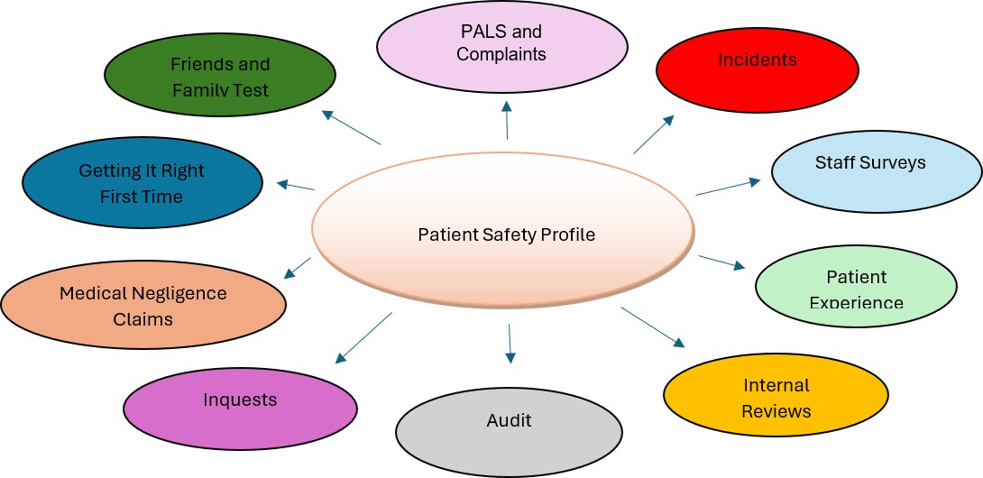

Table 2, Maternity Thematic Analysis:

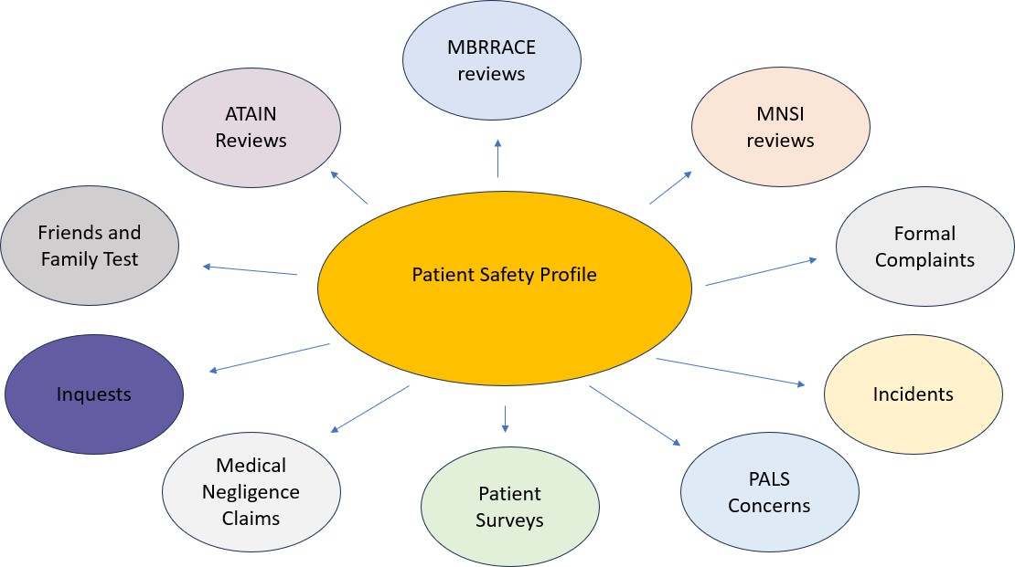

Following the collation of our data, we held discussions on the themes identified within our Trust Quality and Safety Lessons Learnt Forum and these were then presented to the Executive Board to agree the suggested local priorities for investigation.
This review has been undertaken by the Trust’s Quality and Safety Team with support and involvement from the Divisional Leadership Teams, Clinical Medical Leads, Nurses, Midwives, Maternity Voice Partners, Neonatal Teams, Patient Safety Partners, Obstetricians, the Safeguarding Team, Mental Health Team, Workforce and Organisational Development, Freedom To Speak Up Guardians and other stakeholders.

Defining our patient safety improvement profile:
In order to define CHFTs patient safety profile, the views of our stakeholders were collated together with quantitative data and qualitative data sources. Consideration was also given to quality improvement projects already underway and the effectiveness of these. The following themes were identified as common themes across all areas. CHFT has separated the data set for Maternity services.

Trust wide (excluding maternity services): Top 10 local priorities collated from the local patient safety incident review:

Incident Type: | Description: | Response Type (see Appendix B for templates) : | Governance:
Infection | All instances of Healthcare Associated Infections | SWARM (Rapid Incident Review) if required. Checklist incorporating Yorkshire Contributory Factors Framework  Quarterly Thematic Reviews | Infection, Prevention and Control Board.  Divisional Patient Safety Event Review Panel  Quality Assurance Group Divisional Patient Safety Quality Board (PSQB)  Quality Committee
Pressure Ulcers and Tissue Damage | All categories of pressure ulcers and tissue damage resulting from hospital stay or attributed to CHFT community services | SWARM (Rapid Incident Review) if required. Checklist incorporating Yorkshire Contributory Factors Framework  Observation to inform understanding of contextual factors influencing compliance.  Continued monitoring of patient safety incident records to determine any emerging risks/issues.  Quarterly Thematic Reviews | Pressure Ulcer and Tissue Viability Collaborative.  Divisional Patient Safety Event Review Panel  Quality Assurance Group Divisional PSQB  Quality Committee
Slips, Trips and Falls | Patient falls resulting in injury | SWARM (Rapid Incident Review) if required. Checklist incorporating Yorkshire Contributory Factors Framework  Continued monitoring of patient safety incident records to determine any emerging risks/issues.  Quarterly Thematic Reviews | Falls Collaborative.  Divisional Patient Safety Event Review Panel  Quality Assurance Group Divisional PSQB  Quality Committee
Delayed Treatment | Particularly Issues on Movement of Patients/Lost to Follow-up | SWARM (Rapid Incident Review) if required. After Action Review (AAR) +/- Thematic Review | Divisional Patient Safety Event Review Panel  Divisional PSQB Quality Committee
Diagnostic Services | Test Results/Sharing Results | SWARM (Rapid Incident Review) if required. AAR +/- Thematic Review | Divisional Patient Safety Event Review Panel  Divisional PSQB Quality Committee
Deteriorating Patient | Failure to escalate concerns with the deteriorating patient. | SWARM (Rapid Incident Review) if required.  AAR +/- Patient Safety Incident Investigation (PSII) | Divisional Patient Safety Event Review Panel

 |  | Continued monitoring of patient safety incident records to determine any emerging risks/issues. | Divisional PSQB  Care of the Acutely Ill Patient Group.  Clinical Outcomes Group Quality Committee
Communication | Record Keeping /Documentation  /Discharge Planning | SWARM (Rapid Incident Review) if required. AAR +/- Thematic Review | Divisional Patient Safety Event Review Panel  Divisional PSQB Quality Committee
Medication | Incorrect Medications for inpatients/outpatients and discharged (including prescribing, monitoring, administration, supply, and patient information) | SWARM (Rapid Incident Review) if required.  AAR +/- Patient Safety Incident Investigation (PSII) | Divisional Patient Safety Event Review Panel  Medicine Safety Steering Group Divisional PSQB  Quality Committee
Nutrition and Hydration | All instances of patient safety events incorporating nutrition and hydration concerns | SWARM (Rapid Incident Review) if required.  AAR +/- Patient Safety Incident Investigation (PSII) | Divisional Patient Safety Event Review Panel  Divisional PSQB  Quality Assurance Group PSIRF Board  Quality Committee
Consent | Failure to warn – Informed Consent | SWARM (Rapid Incident Review) if required.  AAR +/- Patient Safety Incident Investigation (PSII) | Divisional Patient Safety Event Review Panel  Divisional PSQB  Clinical Outcomes Group Quality Committee

Maternity Services: Top 10 local patient safety priorities:

Incident Type: | Description: | Response Type (see Appendix B for templates) : | Governance:
Unexpected admission to Neonatal Unit (NNU) | All unexpected admissions to the Neonatal Unit. | SWARM (Rapid Incident Review) if required After Action Review (AAR)  +/- Patient Safety Incident Investigation (PSII)  +/- Thematic Review (ATAIN) | Maternity Directorate Governance Meeting  Divisional Weekly Patient Safety Event Review Panel  Divisional Patient Safety Quality Board (PSQB)  Trust Patient Safety Event Review Panel  Trust Quality & Safety Lessons Learnt Forum  Quality Committee
Failure to follow protocol  / escalate | Failure to escalate the deteriorating patient | SWARM  After Action Review (AAR)  +/- Patient Safety Incident Investigation (PSII)  +/- Thematic Review
Category 1 caesarean section | Delay greater than 30 minutes for  Category 1 Caesarean section | SWARM (Rapid Incident Review) if required. After Action Review (AAR)  +/- Patient Safety Incident Investigation (PSII)  +/- Thematic Review
Stillbirth / Neonatal Death | All stillbirths / neonatal deaths occurring in the maternity unit | SWARM  Perinatal Mortality Review Tool (PMRT)  +/- After Action Review (AAR)  +/- Patient Safety Incident Investigation (PSII)  +/- HSSIB/MNSI  +/- Thematic Review
Drug related incident | Omitted drug, wrong dose or frequency | SWARM (As required) After Action Review (AAR)  +/- Patient Safety Incident Investigation (PSII)  +/- Thematic Review
Massive Obstetric Haemorrhage | Antenatal or postpartum haemorrhage over  1500mls | SWARM  +/- After Action Review (AAR)  +/- Thematic Review
Birthing Injury/ Complication | Perineal trauma with Obstetric Anal Sphincter Injury | SWARM (Rapid Incident Review) if required.  +/- After Action Review (AAR)  +/- Patient Safety Incident Investigation (PSII)  +/- Thematic Review
Delay in treatment | Delay in acting on fetal monitoring | SWARM  After Action Review (AAR)  +/- Patient Safety Incident Investigation (PSII)  +/- Thematic Review
Missed small measurement for gestational age | Baby born below the 3rd centile when growth issue not  identified in pregnancy | SWARM (As required) After Action Review (AAR)  +/- Patient Safety Incident Investigation (PSII)

Through our analysis of our patient safety insights, based on the review of the data, we have determined that the Trust requires two patient safety priorities as local focus. This will allow us the capacity to apply a systems-based approach to learning from these incidents, exploring multiple interacting contributory factors.

The priority areas identified, and incident types are set out in the table below and are relevant for all our patient services, including maternity services. Whilst these priorities have been agreed they are not fixed and are open to review. We have also established capacity for an additional ad-hoc PSII, where a new risk emerges or learning, and improvement can be gained from investigation of a particular incident or theme.

Priority Areas:

Patient safety incident type or issue | Planned response
Deteriorating Patient: Failure to escalate concerns around the deteriorating patient | Locally led PSII
Delay in treatment - Particularly Issues on Movement of Patients/Lost to Follow-up and delay in acting on fetal monitoring | Locally led PSII
New emerging risks or where learning and improvement can be gained from a particular incident or theme | Locally led PSII

PSIRF promotes a range of system-based approaches for learning from patient safety events including but not limited to SWARM huddles, Patient Safety Incident Investigations (PSII’s), After Action Reviews, MDT/Case Note Reviews and Thematic Analysis.
CHFT reiterates to all staff, that any of the learning responses could be applied to any of the patient safety priorities, individualised to the case and applied appropriately. Person centred care is pivotal if we are to succeed in continually improving our services for our local population.
The below table demonstrates the learning responses that could be enacted, although these learning responses are not an exhaustive list:

Response Type | What is it? | Who is involved? | Who leads it? | Time required? | Output
SWARM | A rapid response to harm incidents, allowing immediate actions to be implemented | Those directly involved in the event. | Risk Manager, Senior Investigator, Associate Director of Nursing, Divisional  Director | 15 to 30 minutes maximum | Immediate learning with early actions to reduce the likelihood of similar incidents occurring
PSII | System review undertaken to identify new opportunities for learning and improvement | Those who are affected with the event.  Pivotal for patients and families to be included at the outset of the  review | Senior Investigator  Support from Quality Governance Leads | Average of 3 x months | Outline key findings, summarise themes/trends, issues will be identified, and Quality Improvement (Qi)  work completed

AAR | A method of evaluation that is used when outcomes of a patient safety event have been particularly successful or unsuccessful.  The AAR aims to capture learning from these tasks to avoid failure and promote success for the  future. | Those directly involved in the event and others that are part of the patient pathway. | Undertaken by a trained facilitator | Completed within 14 x days of the patient safety event.  Patients and families must be included at the outset. | Learning collated to inform existing Qi projects or commission new.
Case Note/MDT Review | An in-depth process of review which aims to identify learning from an incident or a number of incidents to explore a  theme, pathway or process. | Workstream leads | Senior Lead | Completed within 14 x days of agreed review | Outline key findings, summarise themes/trends, issues will be identified, and Qi work commissioned
Thematic Reviews | A deep dive into themes/trends which will inform further analysis/Qi work. | Workstream leads | Senior Lead  Require knowledge of SEIPs and thematic review toolkit | Average of 30  to 40 hours | Outline key findings, summarise themes/trends, issues will be identified, and Qi work commissioned
ATAIN  review | A  multidisciplinary case of review of all unexpected admissions of a term neonate to the Neonatal  Unit | Members of the multidisciplinary team across midwifery, obstetrics and neonates facilitated by the quality and safety  governance lead | Quality and Safety Governance lead | 15 – 30  minutes | Immediate learning with early actions to reduce the likelihood of similar incidents occurring
PMRT  investigation | A method of evaluation that is used to review a perinatal death with the aim to identify and capture learning to avoid failure and promote success for the  future. | Multidisciplinary team as outlined by MBRACE | Quality and Safety Governance lead | To be completed within 6 months | Outline key findings, summarise themes / trends and inform immediate actions and Quality Improvement (Qi) work as required

Following the Ockenden Interim Report, published in December 2020, external specialist clinical opinion from outside the Trust (but from within the Region) is now mandated for cases for intrapartum death, maternal death, neonatal brain injury and neonatal death. These cases are usually investigated by Maternity and Neonatal Safety Investigation (MNSI) programme,

and the learning from the reports shared with the Trust Board and the Local Maternity Neonatal System (LMNS) for scrutiny, oversight, and transparency. In addition to this, all perinatal deaths must be reviewed using the PMRT tool to meet the requirements within the Maternity Incentive Scheme (MIS). The Trust multi-disciplinary team conducting the PMRT review will include at least one and preferably two of each of the professionals involved in the care of pregnant women and their babies. The MDT PMRT team will also include a member from a relevant professional group who is external to the unit who will provide ‘a fresh pair of eyes’ as part of the PMRT review team; this will ensure bias does not creep into the review.
In line with PSIRF, it is important that no arbitrary timescale is applied to the time in which it will take to complete a PSII. However, where a patient safety investigation for learning is indicated, the investigation must be started as soon as possible after the incident has been identified.

Patient safety investigations should ordinarily be completed within one to three months of the start date.
Where a longer timeframe is required for completion of the patient safety investigation, this will need to be authorised by the Associate Director of Quality and Safety in consultation with the patient/family.
No local patient safety investigation should take longer than six months. A balance must be drawn between conducting a thorough investigation, the impact that extended timescales can have on those involved in the incident, and the risk that delayed findings may adversely affect safety or require further checks to ensure they remain relevant. (Where the processes of external bodies delay access to some information for longer than six months, a completed local safety investigation can be reviewed to determine whether new information indicates the need for further investigative activity.
Please note that any patient safety event that is not considered to meet any of the above criteria but is felt significant enough to warrant escalation to the Trust Patient Safety Event Review Panel can still be discussed within the Quality and Safety Team and the most appropriate route of escalation will be advised. This may include a PSII if the Trust Patient Safety Event Review Panel consider doing so would result in significant learning.

To improve our ability to deliver against PSIIs, the Trust has:

- Assigned a team of appropriately trained PSII investigators who have received systems- based training on incident investigation methodologies.
- Assigned an appropriately trained board member to oversee delivery of PSIIs and support the sign off of all PSIIs.
- Developed an incident investigation toolkit to support other Trust staff so they can review Patient Safety Incidents where a PSII is not indicated but learning can still be identified.

All investigators will be supported by an investigation team which will include a supporting investigator, dedicated patient/family point of contact, administrative and management support. Executive support will be made available from the Executive Chief Nurse and the Executive Medical Director as required. Lead and supporting investigators will not be expected to manage more than 2 PSIIs at any one time.
Please see Appendix D for the Trust incident reporting process.

Trust Learning:
The Trust has established and embedded a Trust Wide Quality & Safety Lessons Learnt Forum. This forum provides assurance that there is effective monitoring and oversight of lessons learnt from patient safety events (incidents, complaints, soft intelligence, inquests, claims etc) across all spheres of Trust activity and that improvement of patient safety is at the heart of all the work that we do at the Trust.
The Trust Quality & Safety Lessons Learnt Forum also provides assurance on the effectiveness of the corporate and divisional arrangements to learn lessons and monitor the impact of safety improvement actions on patient safety, and quality improvement work undertaken across the Trust. Themes from learning will be coordinated into a cohesive programme, monitoring impact, and adjusting where required, and escalate issues to the Quality Committee.

For learning responses that are shared with the His Majesty’s Coroner (HMC), each response much have a cover sheet attached (See Appendix C).

National Priorities:
In addition to the Trust local priorities, there a number of patient safety events that fall within the national priority areas.

National priorities for the reporting and referral of patient safety incidents to other bodies for investigation are described in the table below:

Nationally defined priorities requiring referral for investigation advice

Incident Type: | Response Type:
Incident in screening programmes | PSII  Incidents must be reported to Public Health England (PHE) in the first instance for advice on reporting and investigation (PHE’s regional 15 Screening Quality Assurance Service (SQAS) and commissioners of  the service)
Child Death | PSII (if indicated by the PSIRF panel)  Incidents must be referred to child death panels for investigation
Safeguarding incident: | PSII (if indicated by the PSIRF panel)  Incidents must be reported to the local organisation’s named professional/safeguarding lead manager and the Chief Nurse for review/multi-professional investigation.
Death in custody where healthcare was provided by the NHS | PSII (if the death occurred at CHFT)  Incidents must be reported to the Independent Office for Police Conduct (IOPC). Organisations should contribute to IOPC investigations when approached.
Notification of infectious diseases: | PSII (if indicated by the PSIRF panel)  Incidents must be reported to the local organisation’s DIPC and Chief Nurse for review/multi-professional investigation. Incidents will be managed locally through local review of the incident and through process audit.
Information Governance | PSII (if indicated by the PSIRF panel)  Incidents previously reported under the Serious Incident Framework 2015 must be responded to according to Data Security and  Protection guidance. This includes reporting via the data security and protection toolkit as required
Maternity and neonatal incidents meeting MNSI criteria. This includes Term babies with the following outcomes:  - Intrapartum stillbirth  - Early neonatal death  - Potential severe brain injury unless health issues or congenital conditions (something that is present before or at birth) have led to the outcome for the baby.  - Maternal deaths-direct and indirect  Maternal deaths while pregnant or within 42 days of birth unless suicide. | MNSI led review
Deaths that meet MBRRACE-UK perinatal surveillance. This includes: All late fetal losses and stillbirths (excluding  medical termination) and neonatal deaths | Completion of Perinatal Mortality Review Tool within mandated timeframe. Identify and disseminate learning. Where issues in care have contributed to the outcome consider PSII led by the Trust

Nationally defined incidents requiring local investigation:
National priorities for patient safety investigation are set by the PSIRF and other national initiatives. These are:
- incidents that meet the criteria set in the Never Events list 2018.
- incidents that meet the ‘Learning from Deaths’ criteria; that is, deaths which – following a case note review – are considered more likely than not due to problems in care.

Incident reporting arrangements
Full details of incident reporting arrangements are detailed in the CHFT PSIRF Policy. This will include internal and external notification requirements for the reporting of patient safety- related incidents. All staff are required to:

  - Report all incidents and near misses via the Trust’s electronic incident management system.
  - Ensure the details of any incident are contemporaneously and objectively reported in the patient’s clinical record.
  - Raise any concerns about situations that led to, or could lead to, an incident or a near miss with their line manager or the Patient Safety and Quality Team.
  - Actively participate in any subsequent incident investigation such as: providing a written account of the incident; attending multidisciplinary fact-finding and feedback meetings.
  - Attend a Coroner’s inquest on behalf of the Trust if called to do so.
  - Undertake mandatory training in the reporting of incidents.
  - Undertake additional training, as required, to ensure competence in relation to the InPhase (Safeguard) system.
The Trust will make available appropriate support to those staff involved in an incident, where this is required.

There are specific incidents which may require reporting externally under specific criteria, these are detailed within the PSIRF policy, for the reporting and management of incidents.
See Appendix D for flowchart outlining incident reporting process.

Procedures to support patients, families and carers affected by patient safety incidents:
Engagement is pivotal within any review and CHFT will ensure that effective engagement is maintained with all our patients, families, carers, and staff at the outset and throughout any patient safety investigation.

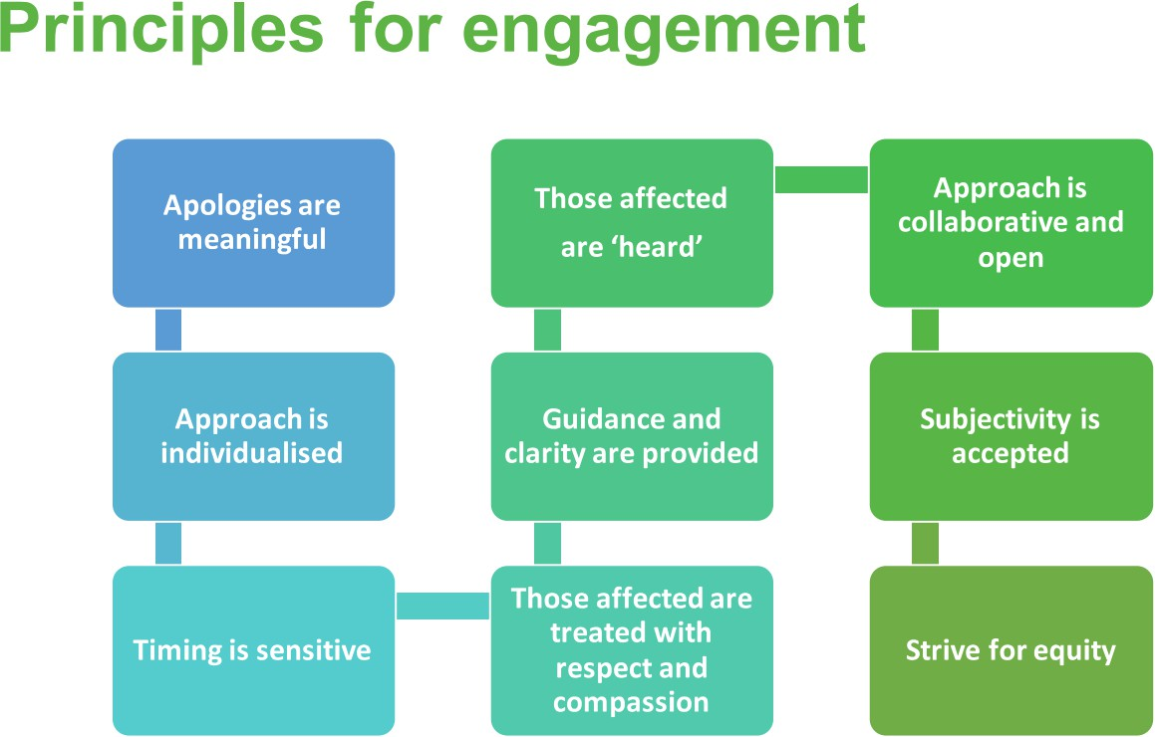

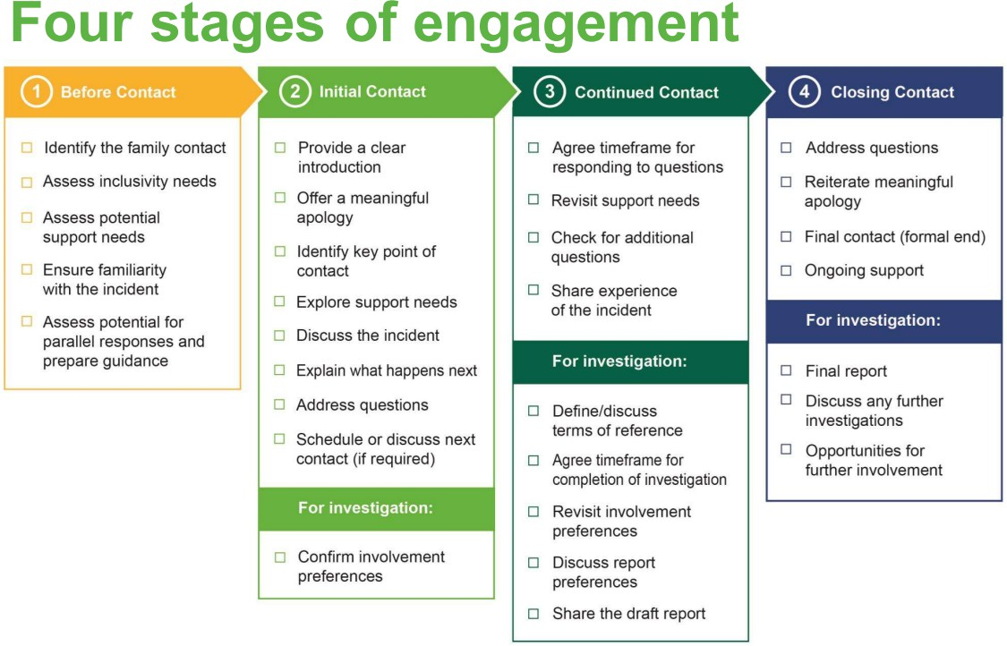

The national and local arrangements for supporting patients, families and carers are:

Named contacts for patients, families, and carers:

  - Each patient/carer will have a named contact identified to facilitate their access to relevant support services.
  - The named contact will have experience of and been trained in ‘being open’ and Duty of Candour.
  - The named contact will have sufficient time to undertake this role.
  - Will support staff training in openness and transparency.
  - Be able to establish a relationship with those affected (and become known to and trusted by the patient, their family, and carers).
  - Be able to offer a meaningful apology, reassurance and feedback to patients, their families, and carers.
  - Have a good grasp of the facts relevant to the incident but be sufficiently removed from the incident itself.
  - Be senior enough or have sufficient experience of and expertise in the type of patient safety incident to be credible to the patient, their family and carers, and colleagues.
  - Have excellent interpersonal skills, including being able to communicate with the patient, their family, and carers in a way they can understand, without excessive use of medical jargon.
  - Have a good understanding of how the incident will be responded to and ensure realistic expectations are set.
  - Be able to liaise with several different individuals and be prepared to help those affected navigate complex systems/processes.
  - Actively listen to patient, family and carer queries/concerns and engage with other staff to ensure these are responded to openly and honestly.
  - Be knowledgeable about and provide access to different types of support (including independent advocacy services as required).
  - Be able to maintain a medium to long-term relationship with the patient, their family, and carers where possible, and to provide continued support and information during the investigation/review process.
  - Be culturally aware and informed about the specific needs of the patient, their family, and carers.

For continuity and consistency of communication, a co-contact will be assigned to support the lead contact and to act as lead contact during times when the first named contact is absent.
Junior staff or those in training must not be appointed as lead named contacts unless accompanied to all meetings with patients, families and carers and supported by a senior team member.

Health Inequalities
The patient safety healthcare inequalities reduction framework was published in May 2025. This framework sets out 5 x principles to reduce patient safety healthcare inequalities across the NHS. CHFTs vision and values align with the principles of this framework and our staff strive to address unfair and avoidable differences in patient safety outcomes across our population footprint in Calderdale and Kirklees.

The framework outlines five key principles:

  - Ensuring accessible information and translation services
  - Embedding inequalities training for all staff
  - Improving diversity data collection
  - Involving diverse communities in co-designing improvements
  - Investing in targeted research.
These principles align with NHS England's wider Patient Safety Strategy and Core20PLUS5 approach, providing practical implementation opportunities for NHS organisations. The framework is enriched with case studies and personal stories to support teams in fostering a culture of inclusive, safe care.

This framework reflects the 6 themes relating to the mechanisms driving heightened risk of preventable harm:
  - enhancing communication
  - encouraging and activating patient engagement in their own care
  - reducing workforce and system biases
  - enabling smooth transitions of care
  - making care accessible
  - empowering insightful data

Core20PLUS5 initially focussed on healthcare inequalities experienced by adults but has now been adapted to apply to children and young people.
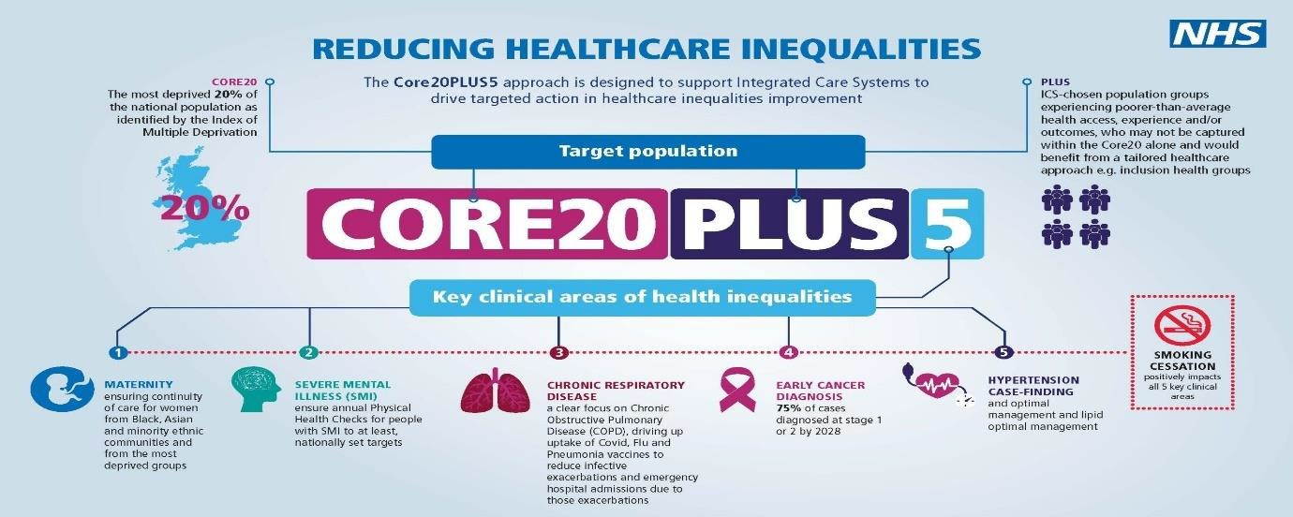

CHFT and its maternity services, has a strong focus on engaging with women and families, recognising that more work is needed to close the gap in health inequalities given that we serve a diverse population.
MBRRACE-UK analysis demonstrates the impact of both deprivation and ethnicity on perinatal and maternal mortality. Improving access to services and tailoring services around the needs of the local population in an inclusive way continues to be part of ongoing work both locally and regionally to reduce inequalities in health.

As a Trust we are aware that individuals’ stories and case studies are powerful for understanding the impact of discrimination on safe care and patient safety healthcare inequalities, and we now collate patient stories regularly to share Trust Wide.
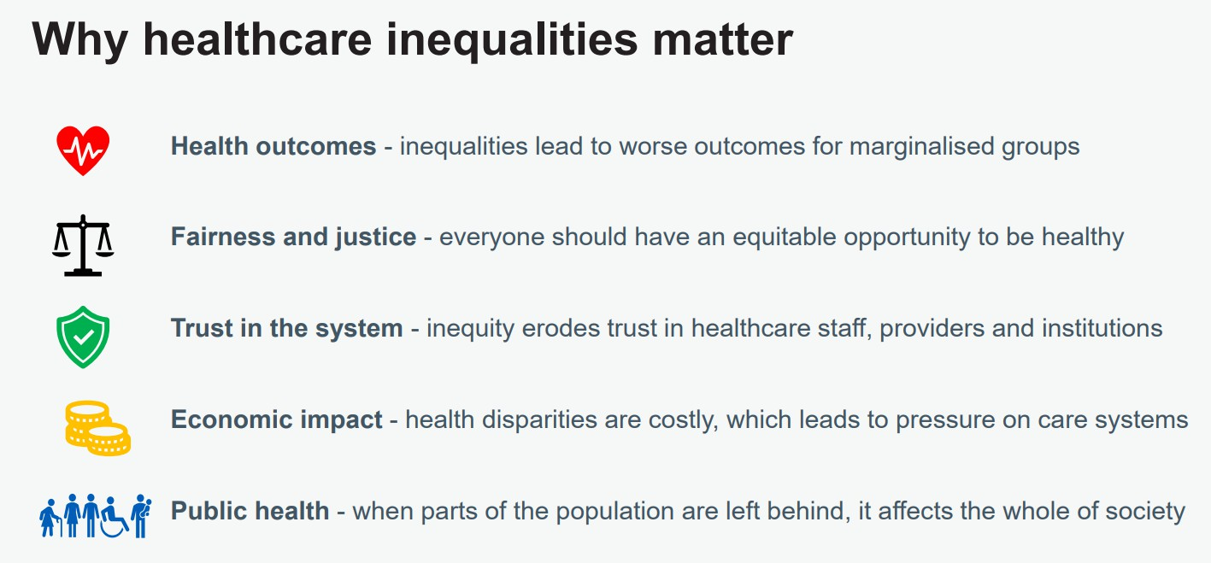

Promoting a Just Culture
Changing culture takes concerted effort and time and CHFT are passionate in improving our Patient Safety Culture throughout the organisation. A just culture is not just about creating a culture of fairness, transparency and learning, it also recognises that success or mistakes are the product of many factors and focuses on changing systems and processes to make it easier for people to do their jobs safely. It is about ensuring everyone is confident they will be treated fairly when something goes wrong.
Safety culture has been a key and recurring theme in reports where there has been poor care (Francis Report; Morecambe Bay and the Ockenden Report) and its importance highlighted in responses in the Berwick Review and the Winterbourne View.

It has become apparent that just culture means different things to different people, and at different hierarchical levels. Without a common understanding of what we perceive safety culture to be, it is difficult to understand how to create a positive shift.

CHFT are continuing to shift the culture by working together as a team and utilising the NHS Scotland’s Safety Culture Cards (safety culture discussion cards (1).pdf) to aid discussions and open conversations around safety and risks.
The structured approach to the communication of safety-critical information, such as tools like SBARs (Situation, Background, Assessment and Recommendation) in specific circumstances are helpful and our Trust approach to Safety Huddles are demonstrating to be an effective way to communicate key information, improve cohesion, build relationships and reinforce share values and purpose.

Underpinning being open and transparent is pivotal to shift people’s mindsets. The use of the NHS Being Fair Tool (Short document template 1) that replace the NHS Just Culture Guide to reduce the role of unconscious bias is supported by the PSIRF and CHFT are slowly moving forwards with this new way of working to ensure psychological safety is actively created and nurtured.

Procedures to support staff affected by patient safety incidents:
CHFT is committed to supporting our staff and are proud to have been awarded a range of accreditation in recognition of our positive employment practice. Alongside being a Disability Confident Employer, CHFT has also signed the Armed Forces Covenant, and our People Strategy sets out our plan for delivering One Culture of Care for all our colleagues.

The Trust provides all staff with an Occupational Health Service which focuses on the physical and mental wellbeing of employees in the workplace. Managers can refer a member of staff for support or alternatively, staff members can self-refer.

The Trust has a Spiritual Care and Chaplaincy Team who are available 24/7 on site or via switchboard for support for staff or patient/carer support following incidents. The Chaplaincy Team are trained to offer diffusing and debrief sessions, as well as offering guidance and signposting for further support.

Free counselling, support and advice is available via the Well-being online website which is available through the Trust’s intranet.

The Trust has two identified Freedom to Speak Up Guardians (FTSU) available via a designated email address. The FTSU will provide support to colleagues if they have raised any concerns to them.

The Trust has an identified Nurse Consultant in Mental Health available via a designated email address.
The Trust has a team of Professional Midwifery Advocates (PMA) and Professional Nursing Advocates (PNA) who are also available to offer support to midwives and nurses by adhering to the A-EQUIP model. Colleagues can contact a PMA / PNAs via the dedicated email address.

Named contacts for staff:

  - Facilitate private and confidential conversations with staff affected by a patient safety incident.
  - Work with line managers to provide advice and support to these staff.
  - Facilitate their access to additional support services as required.
  - Liaise between these staff and review/PSII teams as required.
  - Support staff training in recognising the signs of stress and post-traumatic stress disorder in themselves and others and how to access help and support.
  - Work with the patient safety team and other services to prepare/inform the development of different support services.

Mechanisms to develop and support improvements following patient safety investigations:
The national and local mechanisms to develop and support improvements are:

  - Measurement is fundamental to any improvement programme. Without it, organisations may invest time and effort implementing changes that have little or no impact or, in the worst case, increase the risk of further harm. From the start those responsible for implementing improvements/solutions must establish procedures to monitor actions and determine whether they are having the desired effect. Both outcome and process measures should be used to interpret the impact of actions and to inform how actions should be adapted if they fail to have the desired effect.
  - Maintaining an action log throughout the PSII to ensure identified improvements are actioned in a timely manner as identified.
  - Monthly reporting of improvements identified, and actions being taken to complete.
  - Identification of Quality Improvement projects requiring a lead and registration and support through the Quality and Safety Team
  - Identification of potential trust-wide transformation projects and proposals for transformation team support

Evaluating and monitoring outcomes following patient safety investigations and reviews
  - Robust findings from investigations and reviews provide key insights and learning opportunities, but they are not the end of the story.

  - Findings must be translated into effective improvement design and implementation. This work can often require a different set of skills from those required to gain effective insight or learning from patient safety reviews and investigations. The Quality & Safety Team along with the Workstream Leads with our communities of practice will support improvement design.

  - Reports to the board will be quarterly and will include aggregated data on:

    - patient safety incident reporting
    - audit and review findings
    - findings from patient safety incidents
    - progress against the PSIRP
    - results from monitoring of improvement plans from an implementation and an efficacy point of view.
    - results of surveys and/or feedback from patients/families/carers on their experiences of the organisation’s response to patient safety incidents
    - results of surveys and/or feedback from staff on their experiences of the organisation’s response to patient safety incidents

In addition to the above, the Trust ‘Information Performance Report’ will provide the board with oversight of key quality and safety metrics.

PALS & Complaints
CHFT will ensure that effective engagement is maintained with all our patients, families, carers, and staff at the outset of any patient safety event reported. It is hoped that by involving our patients and their families from the outset will avoid having use the complaints route of engagement.
Local arrangements for complaints and appeals relating to the organisation’s response to patient safety incidents are:

- The Trust’s Complaints Handling Policy is for patients, their carers, relatives, or friends to raise concerns regarding the care and treatment of a patient. Concerns are raised via Patient Advice and Liaison Services (PALS) or through a formal complaint. The Complaints Team, the Legal Team and Patient Safety Team work closely to ensure aligned and effective approaches in response to patient safety incidents.
- PALS offers patients, families and carers confidential advice, support, and information on health-related matters. As well as informally helping to resolve issues, PALS can guide people on filing a formal complaint and advise on accessing advocacy services.
- Everyone has the right to make a complaint about any aspect of NHS care, treatment, or service. The NHS website gives guidance on how to do this and details of local advocacy providers. The independent NHS Complaints Advocacy Service will provide someone to help navigate the NHS complaints system, attend meetings, and review information given during the complaints process. Local Healthwatch also provides information about making a complaint, including sample letters.
- Parliamentary and Health Service Ombudsman makes the final decisions on complaints patients, families and carers deem not to have been resolved fairly by the NHS in England, government departments and other public organisations.

Learning from complaints are now presented at the Trust Quality and Safety Lessons Learnt Forum to ensure it is shared wider to aid improvements.

Roles and responsibilities
CHFT describes clear roles and responsibilities in relation to its response to patient safety incidents, including investigator responsibilities and upholding national standards relating to patient safety incidents.

Chief Executive and Board of Directors:
The principal accountability of all providers of care is to patients and their families/carers. In their fulfilment of the Trust’s duty in this regard, the Board must ensure that an appropriate incident management system is in place for the reporting of incidents and monitoring of incident trends, including PSIIs and the recording of all Never Events in the annual reporting arrangements. The Board must ensure that the patient safety incident response framework is implemented from ward to board. Provider organisations are also accountable for effective governance and learning through assurance of their PSIRP, and it is the duty of the Board to ensure appropriate arrangements are in place throughout the Trust to meet this expectation. The Board takes responsibility for creating a just, open and learning culture within the organisation and for role modelling the behaviours required to achieve this.

The Chief Executive is accountable and responsible to the Board for ensuring that resources, policies, and procedures are in place to ensure the effective reporting, recording, investigation and treatment of incidents.

The Chief Executive has:

- Overall responsibility for ensuring the organisation has processes that support an appropriate response to patient safety incidents (including contribution to cross- system/multi-agency reviews and/or patient safety incident investigations (PSIIs) where required).
- Overall responsibility for ensuring the development of a patient safety reporting, learning and improvement system.
- Ensures that systems and processes are adequately resourced: funding, management time, equipment, and training.
- Appoints executive lead for supporting and overseeing implementation of the PSIRF.
- Approves publication and ongoing review of the organisation’s patient safety incident response plan (PSIRP).
- Ensures that the PSIRF, patient safety incident reporting data, patient safety incident investigation data, findings, improvement plans, and progress are discussed at the board’s quality subcommittee.
- Ensures that the organisation complies with internal and external reporting/ notification requirements.
- Acts as spokesperson in complex/high profile cases where the media/public is engaged.

Executive Chief Nurse:
The Chief Nurse is the nominated Director responsible for ensuring the Trust has appropriate arrangements in place for the management of incident reporting and associated investigation. The responsibility for defining and verifying an adverse event as a PSII rests with either the Chief Nurse or the Medical Director (or the Chief Executive in their absence) as part of the Patient Safety Incident Response Plan. Once verified, the Associate Director of Quality & Safety or his/her deputy will ensure the appropriate internal and external reporting is carried out and the investigation commences in accordance with this policy and procedure.

Executive Medical Director:
The responsibility for defining and verifying an adverse event as a PSII rests with either the Chief Nurse or the Medical Director (or the Chief Executive in their absence) as part of the Patient Safety Incident Response Plan. The Executive Medical Director is the Trust’s lead in the formation and implementation of clinical strategy, taking a lead on clinical standards in relation to the quality and safety of patient care, and providing clinical advice to the Board.

Directors/Executive Team:
All Directors are responsible for ensuring incident reporting arrangements as described in this policy are implemented throughout their service areas. The Executive Team ensures accountability from divisions regarding the implementation of actions and dissemination of learning following serious incidents, or other incident trends highlighting emerging issues. It receives assurance that the Trust’s Being Open and Duty of Candour policy is adhered to in terms of informing patients and/or relatives of incidents and the subsequent sharing of reports.

Associate Director of Quality and Safety:
The Associate Director of Quality and Safety is responsible (on behalf of the Chief Nurse and the Medical Director) for ensuring the following systems are in place and operate effectively:

- Ensures that the organisation has processes that support an appropriate response to patient safety incidents (including contribution to cross-system/multi-agency reviews and/or investigation where required).
- Ensures that processes for preparing for and responding to patient safety incidents are reviewed as part of the overarching governance arrangements.
- Ensures that the executive and non-executive team can access relevant safety incidents, including the impact of changes following incidents.
- Oversees development and review of the organisation’s PSIRP.
- Agrees sufficient resources to support the delivery of the PSIRP (including support for those affected, such as named contacts for staff, patients, families, and carers where required.
- Ensures that the Duty of Candour is upheld.
- Ensures that the organisation complies with the national PSII standards.
- Establishes procedures for agreeing patient safety investigation reports in line with the national PSII standards.
- Develops professional development plans to ensure that staff have the training, skills, and experience relevant to their roles in patient safety incident management.
- Provides leadership, advice, and support in complex/high profile cases.
- Liaises with external bodies/supports the Chief Executive as a spokesperson for the organisation as required.

The Associate Director of Quality and Safety will meet these duties through delegated responsibility to the Head of Quality and Patient Safety and the Patient Quality and Safety Team.

Patient Safety Specialists:
CHFT currently have six Patient Safety Specialists (PSS). The Executive Chief Nurse, Deputy Chief Nurse, Associate Medical Director, Associate Director of Quality and Safety and the Head of Quality and Patient Safety are the nominated PSSs. The designated PSSs within CHFT provide dynamic senior patient safety leadership. Each PSS plays a key role in the development of a patient safety culture, safety systems and improvement activity. Each PSS also facilitates the escalation of patient safety issues or concerns and has direct access to the Executive Team. The PSSs will coordinate and support CHFT’s local patient safety priorities that are outlined in this document. All the PSSs have close links with the NHS England and NHS Improvement National Patient Safety Team who host a national network for Patient Safety Specialists, including regular meetings and information sharing through a dedicated national forum.

Patient Safety and Quality Team:
The Patient Safety and Quality Team has delegated day-to-day management responsibility for the Trust’s electronic incident management system together with all other systems related to the recording, analysis and tracking of incidents and associated action plans. The team must also:

- Ensures that PSIIs are undertaken for all incident that require this level of response (as directed by the organisation’s PSIRP)
- Develop and maintain local risk management systems and relevant incident reporting systems, including the National Reporting and Learning System (NRLS), the Strategic Executive Information System (StEIS) and its replacement, Learning From Patient Safety Events (LFPSE) once introduced, to support the recording and sharing of patient safety incidents and monitoring of incident response processes.
- Support the development and review of the organisation’s PSIRP.

- Ensure the organisation has procedures that support the management of patient safety incidents in line with the organisation’s PSIRP (including convening review and PSII teams as required and appointing trained named contacts to support those affected).
- Establish procedures to monitor/review PSII progress and the delivery of improvements.
- Work with the executive lead to address identified weaknesses/areas for improvement in the organisation’s response to patient safety incidents, including gaps in resource including skills/training.
- The Quality Governance Leads will help to support and advise staff involved in the patient safety incident response.

Patient safety incident investigators:
Patient safety incident investigators must have been trained in systems based thinking and human factors. They must also:

- Ensure that they undertake PSIIs in line with the national PSII standards.
- Ensure that they are competent to undertake the PSII assigned to them and if not, request it is reassigned.
- Undertake PSIIs and PSII-related duties in line with latest national guidance and training.
- Identify those affected by patient safety incidents and their support needs.
- Provide them with timely and accessible information and advice.

Patient Safety Partners:
A patient safety partner (PSP) is actively involved in the design of safer healthcare at all levels in CHFT. This includes roles in safety governance – e.g. sitting on relevant committees to support compliance monitoring and how safety issues should be addressed and providing appropriate challenge to ensure learning and change – and in the development and implementation of relevant strategies and policies.

The PSP will ensure that any committee/group of which they are a member considers and prioritises the service user, patient, carer and family perspective and champions a diversity of views.
Clinical Directors/Associate Directors/Department Leads/Managers: All department leads and managers must:

- Encourage the reporting of all patient safety incidents and ensure all staff in their department/division/area are competent in using the reporting systems and have time to record and share information.
- Ensure that incidents are reported and managed in line with internal and external requirements.
- Ensure that they and their staff periodically review the PSIRF and the organisation’s PSIRP to check that expectations are clearly understood.
- Provide protected time for training in patient safety disciplines to support skill development across the wider staff group.
- Provide protected time for participation in reviews/PSIIs as required.
- Work with the patient safety team and others to ensure those affected by patient safety incidents have access to the support they need.
- Support development and delivery of actions in response to patient safety reviews/PSIIs that relate to their area of responsibility (including taking corrective action to achieve the desired outcomes).
- Lead the local learning response as indicated in the PSIRP for example : After action reviews, SWARMS.

- Develop communication strategies that ensure learning is disseminated effectively supported by a robust process of escalation when needed.

All staff:

All staff Trust wide must:
- Understand their responsibilities in relation to the organisation’s PSIRP and act accordingly.
- Know how to access help and support in relation to the patient safety incident response process.

Commissioners and commissioning organisations (including ICBs, CQC, NHS England):
All our stakeholders must:
- Assess effectiveness of systems and processes to respond to patient safety events in NHS-funded provider services as demonstrated by the behaviours of openness and transparency; the existence of a just culture; evidence of continuous learning and improvement.
- Support/enable co-ordination of cross-system review/investigation where activity cannot be managed at the provider level because the incident is unusually complex/difficult or costly to manage due to multiple providers and/or services being involved across a care pathway.
- Provide improvement support where weaknesses are identified in a provider’s systems and processes for responding to patient safety incidents.
- Share insights and information between organisations/services that have demonstrably improved care and or reduced risk.
- Annually review provider organisations’ progress against investigation/review plans.

Specific roles/responsibilities - Patient safety incident response plans (PSIRPs):

The Head of Quality and Patient Safety along with the nominated Patient Safety Specialists must:
- Work with local system leaders, assure effective application of local PSIRPs and national patient safety investigation standards.
- Monitor and review the PSIRP and ensure that it forms part of the overarching quality governance arrangements.
- In line with recommendations from the Kirkup Review of Liverpool Community Hospital Trust, where a regulator or oversight organisation has concerns regarding the safety of NHS-commissioned services, additional information and assurance will be sought from the provider. If this involves the commissioning of an independent investigation or review, this will be additional to those in the provider’s PSIRP.

Supporting cross-system patient safety investigations:
All commissioning systems must develop their capacity and capability, where these are insufficient, for co-ordinating cross-system investigation and have systems to recognise incidents that extend beyond local boundaries and may require co-ordination at a regional level.

Information sharing to support patient safety investigations:
Records will need to be shared when commissioning and undertaking patient safety investigations, in line with information governance structures and relevant guidance, regulation and legislation. Commissioners should assist in this process.

Summary
By following this plan. CHFT will ensure that it has the correct oversight and governance processes in place Trust wide.

Appendix A:
Glossary of Terms

Term and abbreviation | Definition/description
Patient Safety Incident  Response Framework (PSIRF) | A new NHS framework, published in August 2022 which sets out the NHS’s approach to developing and  maintaining effective systems and processes for responding to patient safety incidents for the purpose of learning and improving patient safety.
Patient Safety Incident  Response Plan (PSIRP) | Describes the approach an organisation will take to address national safety priorities and its specific local  safety priorities, to meet the requirements of the PSIRF.
Patient Safety Incident Investigation (PSII) | An in-depth review of a single patient safety incident (or cluster of events) undertaken by a Lead Investigator, trained in the systems approach to learning from patient safety incidents
After Action Review (AAR) | A structured and facilitated discussion of an event which includes the individuals involved in understanding why the actual outcome differed from the expected, what can be learned and improved upon.
Multi-disciplinary Team (MDT)  Review | An in-depth process of review, with input from different disciplines, including those involved, to identify  learning from multiple patient safety incidents, explore themes, systems, and processes.
SWARM (Rapid Patient  Safety Event Review) | An immediate review of an event for the purpose of addressing immediate patient safety and staff well-  being needs.
Thematic Review | A deep dive into identified themes and issues for a particular group of patients or events, to inform further  analysis and/or align with improvement work.
Systems Engineering Initiative  for Patient Safety (SEIPS) | A problem-solving tool which prompts the examination of the interactions between the component parts of  a complex healthcare work system.

Appendix B:
Learning Responses:

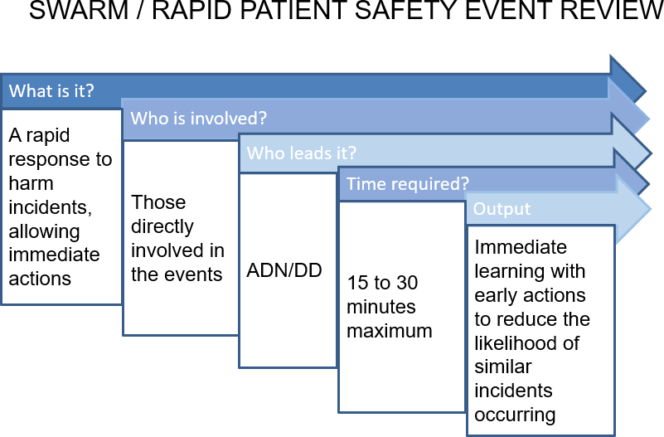

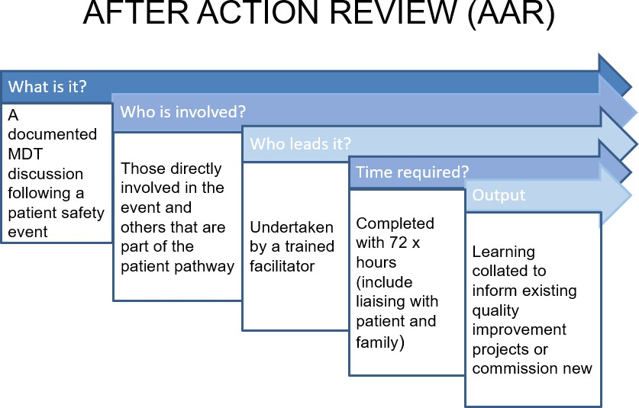

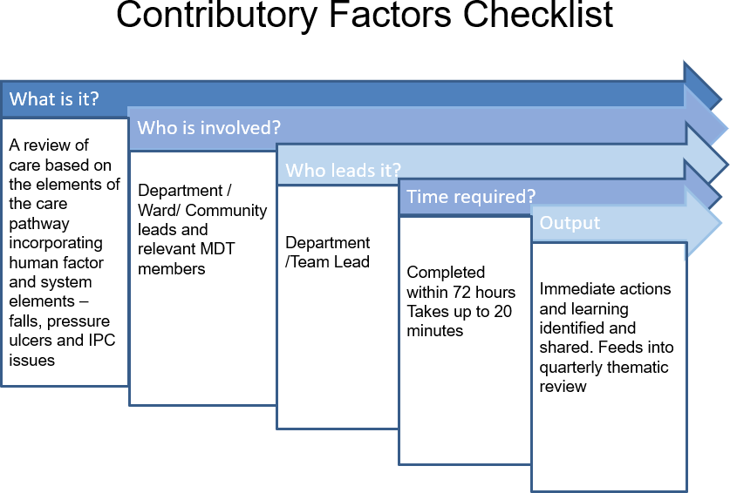

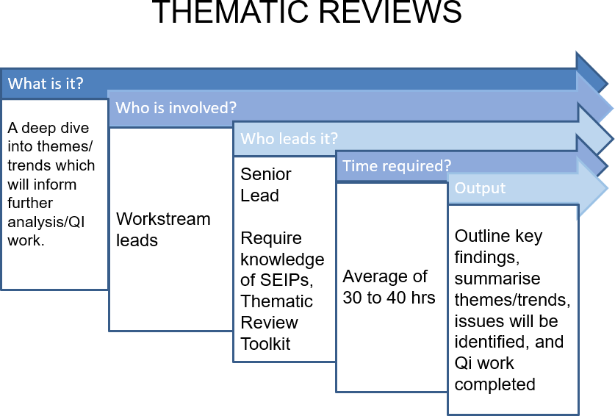

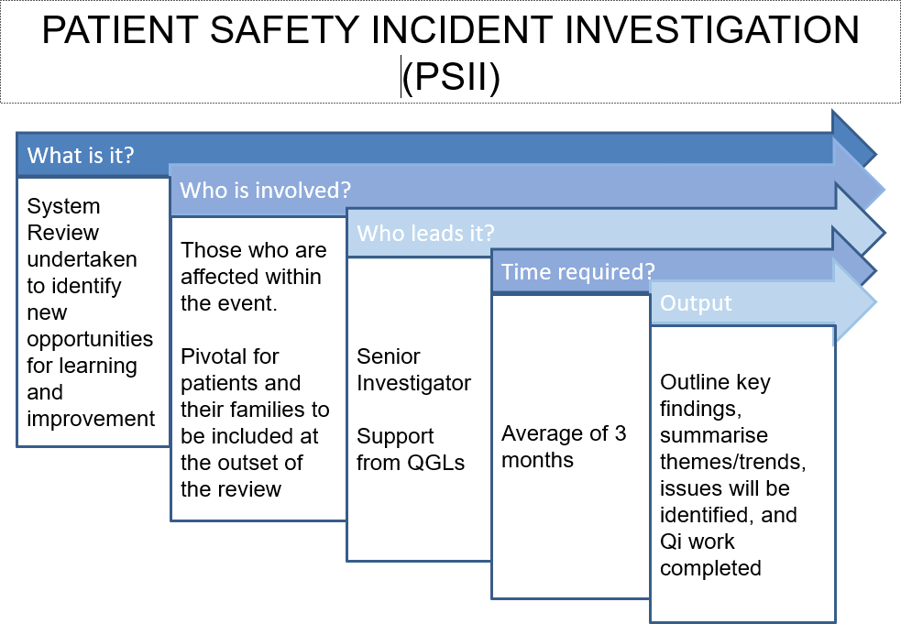

Appendix C: Cover Sheet for Trust Learning Responses for Submission to HM Coroner

Name of the deceased and Patient Identifiers:
Safety Event Investigation Title & Summary:
Type of Investigation Undertaken:
Investigator(s) and Job Titles:
Investigation Report Date:
Key Findings:
Cover Sheet Completed by:

Appendix D:
Flowchart outlining incident review process.
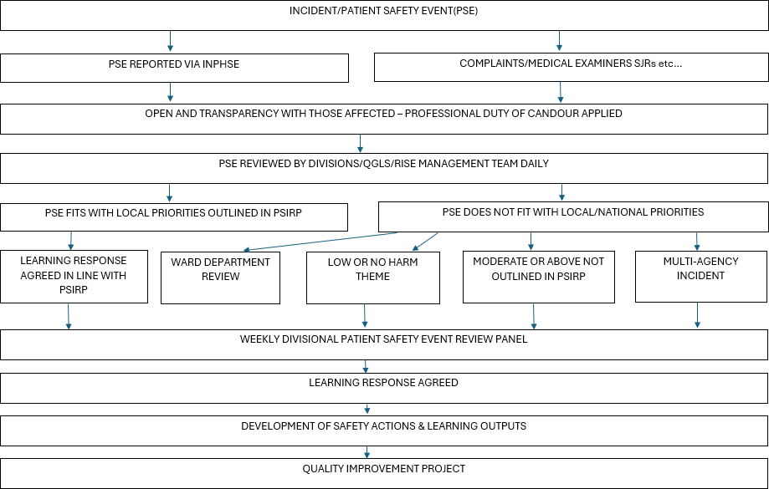

UNIQUE IDENTIFIER NO: G-142-2024

Review Lead: Head of Quality and Patient Safety Review Date: September 2027

Appendix E:

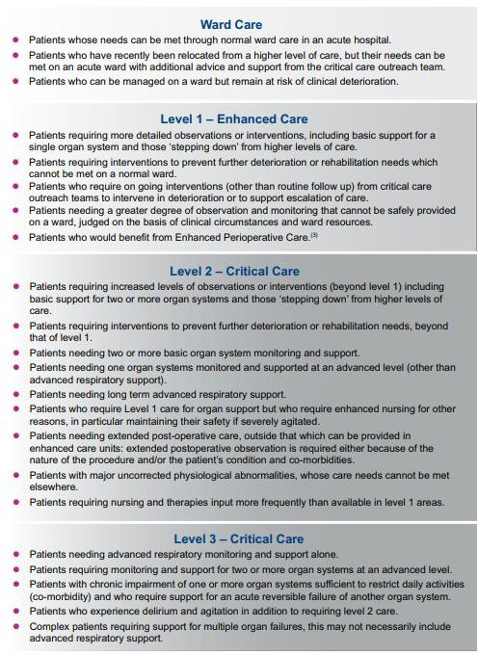


Calderdale and Huddersfield
NHS Foundation Trust

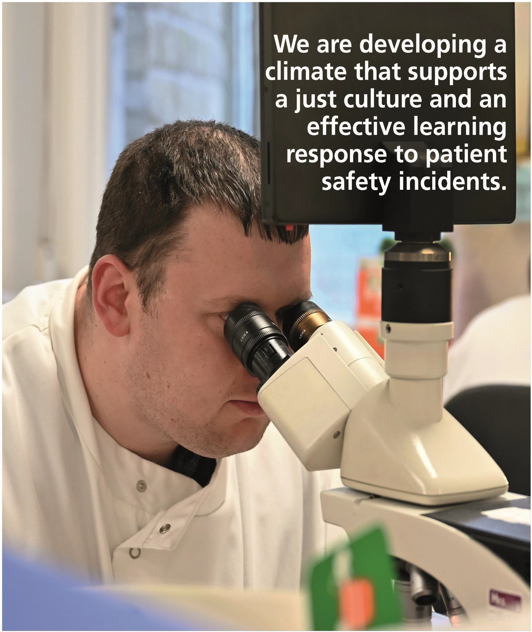


Calderdale and Huddersfield

NHS Foundation Trust

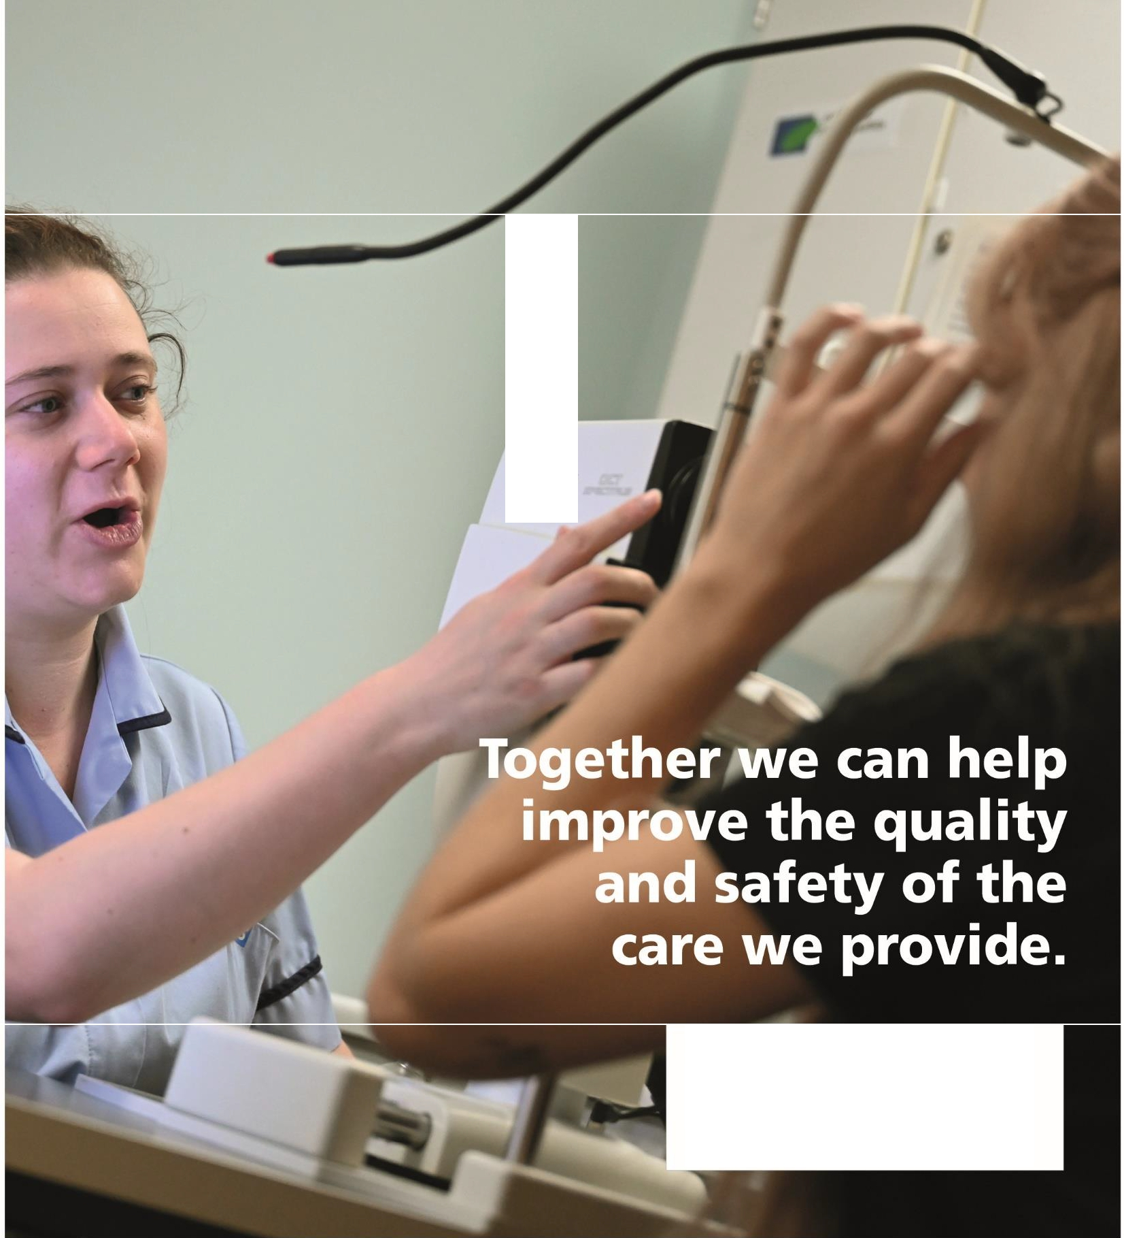
IHEOE,BDS
ETEr£EfrSI

For more information contact:
Sharon Cundy
Head of Quality & Patient Safety Email: sharon.cundy@cht.nhs.uk


one

