

An Introduction to  Pulmonary  Rehabilitation |  | Calderdale Pulmonary Rehabilitation  St.John’s Health Centre  Lightowler Road  Halifax, HX1 5NB  Telephone: 01422 307356

What is Pulmonary Rehabilitation?
Pulmonary Rehabilitation aims to help people with a longstanding lung disease overcome the fear of breathlessness which gradually prevents them from doing day to day activities.

A person with lung disease may also become breathless because they are unfit.

Although Pulmonary Rehabilitation cannot improve the damage caused by lung disease, it can help people cope better with breathlessness; extend their activities and take control of their lives.

You may be referred for Pulmonary Rehabilitation by your GP, Practice Nurse, Specialist Nurse or Consultant. The first step will be an assessment by a physiotherapist. This will establish if the group is suitable for you. This initial assessment will occur at the Physiotherapy Department at Calderdale Royal Hospital. Please bring your inhalers with you, a list of your medication.

The Pulmonary Rehabilitation Groups are run at Old Crossleyeans Sports Club, Halifax and Brighouse Sports Club and consists of supervised simple exercise and educational sessions.

You will learn how to cope with your breathlessness in a safe environment. Gradually you can increase your ability to complete activities and simple exercise. You will be encouraged to continue at home and after you have completed the programme.

The educational sessions cover topics such as your lung condition, breathing exercises, medication, diet, energy conservation and relaxation, provided by a variety of health care professionals.

How often do I have to attend?
The programme runs twice a week, on a Monday and Wednesday in Halifax and Tuesday and Thursday in Brighouse, and is an 8 week course (16 sessions).

To gain any benefit you need to be motivated and committed to attend all sessions, and incorporate the recommended exercise and coping strategies into your daily life.

How do I get there?
Both venues have ample free car parking at both venues; and both venues are on public transport routes. There is a transport service should you need it, there is a small fee, £1 per return journey payable to the driver on the day.
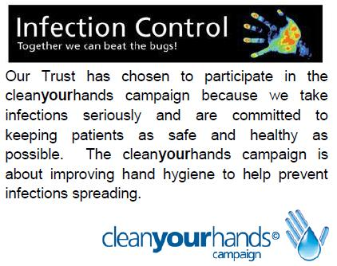
Who runs the course?
The course is run by physiotherapists.

What should I take to the class?
Please wear comfortable clothes and shoes. Bring your blue inhaler with you for exercising and a cold drink.
Initial assessment occurs in the

Physiotherapy Department
2nd Floor
Calderdale Royal Hospital
Halifax
HX3 0PW

Pulmonary Rehabilitation occurs at

Old Crossleyeans Sports Club
Broomfield Avenue,, Halifax, HX3 0JE

Brighouse Sport & Social Club
Russell Way, Brighouse, HD6 4LX

More information : http://www.cht.nhs.uk/services/clinical-services/pulmonary-rehabilitation/

Personal Safety Statement
Under no circumstances will the Trust tolerate any aggressive, abusive or disruptive behaviour towards staff. Persons doing this may be refused treatment.

What our patients say


