Acute Liaison Nurses
Easy Read Information
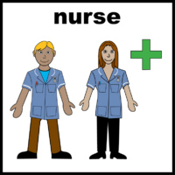
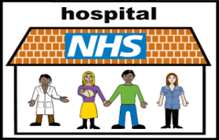 | The Acute Liaison Nurses work in the hospital
 | They work with you and your family or carer when you are in hospital to make sure you get the right care
 | The Acute Liaison Nurses help staff to understand the needs of people with a learning disability
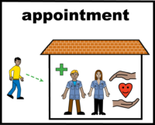 | They can help to plan your appointments and come to your appointment with you
 | They can give you easy read information to make sure you understand
 | They can help staff to make the changes to make it easier for you. For example, using pictures/large print or Makaton
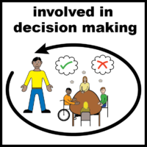 | They can help you make decisions and support you
 | If you feel nervous, they can show you around the hospital
 | They can answer your questions about coming into hospital or about your appointment.
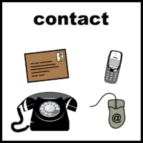 | You can contact the Acute Liaison Nurse yourself or ask someone at the hospital to contact them for you
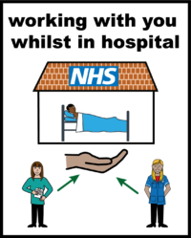 | If you would like an Acute Liaison Nurse to help you at either Huddersfield Royal Infirmary or Calderdale Royal Hospital  Call 01484 343438
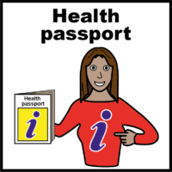 | It would be a good idea to bring your hospital/health passport.  If you need a hospital/health passport contact:  The Acute Liaison Team  01484 343438  LearningDisabilityTeam@cht.nhs.uk  Or  Community Learning Disability health team:  Calderdale – 07795 884879  Kirklees – 01924 316714  Or your GP practice
Further information is available from:

Calderdale and Huddersfield Foundation Trust - https://www.cht.nhs.uk/services/clinical-services/learning-disabilities/

NHS - https://www.nhs.uk/conditions/learning-disabilities/going-into-hospital/

Mencap - https://www.mencap.org.uk/what-we-do/campaigns-and-activism/visiting-hospital

Easy read - https://www.mencap.org.uk/easy-read-library


